[Sales and CRM Overview](https://www.coursera.org/learn/sales-and-crm-overview/home/welcome)

Welcome to the Professional Certificate!

[MUSIC] I probably don't have to tell you this, but now is a critical time to learn Salesforce. The economy is going through a lot of change and upheaval, and more jobs are requiring digital skills. In the last year alone, nearly 3 million jobs were posted that require experience with Salesforce. Foundational Salesforce knowledge is an incredibly valuable skill set to have in the modern economy. Hello, everyone, and welcome to the Salesforce sales operations specialist professional certificate. My name is Anthony Jones, and I will be one of your instructors. Before we talk about how this certificate will teach you the hands on skills you need to start a successful career with Salesforce. I want to take a moment to introduce myself and tell you why I'm excited to be a part of your learning experience. So a little bit about me, I was born and raised in California. I'm a diehard Golden State Warriors fan, and before I came to Pathstream, I worked in education for nearly 15 years, teaching students from all ages and backgrounds. The longer I worked in traditional education, though, the more I realized that there was a pretty big problem. The students I saw weren't learning what they needed to know to get high demand jobs, and many of them were graduating without the digital skills they needed to succeed in the modern economy. That's why I came to Pathstream, at Pathstream our mission is to prepare students for high demand digital skills careers like the one you are about to embark upon in this certificate. For the last year and a half, I've collaborated with Salesforce administrators, salesforce developers, and other subject matter experts across different sales teams from all over the United States to answer one single question. What is the best way to learn the foundational skills in Salesforce to start a new career? The answer to that question can be found in the videos, readings, and hands on Salesforce projects that make up the four courses in this professional certificate. Let's talk a little bit more about each course. The first course will provide you an overview on sales and CRM for those who are new to the subject matter and get you up and running on the Salesforce platform.

Play video starting at :2:15 and follow transcript2:15

The second course will go into depth with lead management in the Salesforce sales cloud. The third course will go into depth with Opportunity management in the Salesforce sales cloud. And the fourth course will cover how to effectively leverage Salesforce data with reports and dashboards in the sales cloud and how to tackle customer success in Salesforce in the Service Cloud. With these foundational Salesforce skills, you'll be ready not only for a sales ops specialist job but any entry level sales role. And you might even find yourself on the path to becoming a Salesforce administrator, which will tell you more about later. Personally speaking, I'm very proud about how real world the content in each courses and how much the project work mirrors what you have to do on the job. I designed a lot of this curriculum, and I can tell you that this certificate is focused on putting you in real world situations where you have to work hands on with the software to learn the skills of today's Salesforce users. Keep in mind, though, online learning could be tough. You have to manage your schedule and set aside time for coursework. To be successful in this professional certificate, we suggest you create a weekly schedule for yourself and routine around when you can log in and work. We also recommend that you don't skip content but really dive into each lesson and do all the assignments. Go hands-on with Salesforce, that's how you're going to get the most out of this experience. Finally, I'm excited to be with you during your learning journey. There are other people on the learning design team here at Pathstream that you will hear from throughout the certificate, but you can think of me like your personal coach or your number one cheerleader for your learning experience. You'll hear from me mostly at the beginning of new modules. But I'll also popped by sometimes to reiterate key points in a lesson for you and to wrap everything up at the end of the course. It's an honor not only for me, but for everyone here at Pathstream and our partners at Coursera that you trust us to help you gain your new Salesforce skillset. You're learning is something we take very seriously and we don't feel like we've succeeded until you succeed. So without further ado, let's dive in. In the next video, you'll learn a little bit more about the sales operations specialist role and why foundational Salesforces skills make up such a critical part of the job, enjoy. [MUSIC]

What is Pathstream?

At this point you might be wondering, what is Pathstream exactly?

At our core, we are an education company building a new type of online learning experience focused on real job outcomes for students. In this professional certificate, we have partnered with Coursera to bring our curriculum to you so that you can start your journey to a new career with Salesforce.

If you'd like, [check out this episode of the Pathstream Podcast with Eleanor Cooper, the CEO and Co-founder of Pathstream, to hear more about our mission](https://youtu.be/xP2gy-HDv9Y).

Here's a little bit more about who we are and what drives us:

Who We Are

We’re a tight-knit, hardworking, mission-driven team that is eager to prepare students of all ages for high-demand digital skill careers and transform education. [Learn more about us and come meet the team!](https://www.pathstream.com/team)

What We do

Pathstream partners with leading technology companies to build branded digital skills career programs delivered through college and university partnerships. Our programs are for anyone who wants to learn the digital skills needed to succeed in the modern economy.

Our mission is to create the most accessible and effective career pathways to jobs in the modern economy. Digital skills like Salesforce are required for most of the highest-demand careers, yet most students graduate without them. We aim to fill this gap with specialized instructor and career coaching support, ensuring that all jobseekers can gain the skills to access good jobs (defined as full-time employment opportunities with multiple career paths and annual salaries of at least $50k) in the modern economy.

**If you ever feel like you need more personalized, human support with your learning and career goals, Pathstream offers mentors and coaches to meet your individual needs.**

Now that you know a little more about us, [feel free to drop by at any time during this professional certificate to say hi!](https://www.pathstream.com/contact)

**The Sales Operations Specialist Role**

[MUSIC] Over 3 million jobs requiring Salesforce skills were posted in the last 12 months. And the demand for professionals with CRM and Salesforce experience is still growing. One of the jobs that is currently in high demand is the Sales Operations Specialist role. **Sales Operations Specialists, also known as Sales Ops Specialists, leverage the powerful tools in Salesforce to support and empower sales teams to sell more effectively**. While the exact job structure and responsibilities will vary from business to business, generally, **a Sales Ops Specialist will provide value under four main categories.**

**Strategy, for example, providing sales forecasting through the use of Salesforce data and offering ideas on how to optimize the sales process**.

**Technology, like leading the adoption and customization of a CRM like Salesforce, as well as the other integrations in the sales team's tech stack.**

**Operations, such as finding the best use of the many tools in Salesforce, to make the sales and support teams work more efficient**.

**And performance, using reports to leverage Salesforce data, for example, to determine how effectively and efficiently the members of the sales team are doing their jobs**. Keep in mind that, depending on the company, **the Sales Ops Specialist role might go by a variety of different names like Sales Support Specialist, Revenue Operations Specialist, or sometimes even just Sales Representative.** Every organization defines the responsibilities of this role differently, but the one constant that you need to do this job well, is a strong foundation in Salesforce. Which the courses in this professional certificate will give you.

Play video starting at :1:41 and follow transcript1:41

**Some examples of how a Sales Ops Specialist might use Salesforce to complete real-world tasks on the job include, optimizing lead management. For example, a Sales Ops Specialist might see that the way a sales team is targeting and communicating with potential new customers is inefficient. And then suggest ways to improve the process using Salesforce.**

Play video starting at :2:2 and follow transcript2:02

**Creating a system for opportunity management by showing a sales team how to progress sales opportunities through the stages in a sales cycle in an organized, scalable way in Salesforce. Ensuring consistent and quality customer support, by implementing the clear support process using the tools in the Salesforce Service Cloud.** And generating reports and dashboards in Salesforce, in order to track a sales team's performance and forecast future sales.

Play video starting at :2:29 and follow transcript2:29

Overall, being familiar with the foundations of how Salesforce is used, is incredibly important for anyone interested in the Sales Operations Specialist role, or any sales role, for that matter. Knowing how to leverage these fundamental tools in Salesforce will enable you to support and empower teams to sell more effectively and support customers along the way.

Play video starting at :2:50 and follow transcript2:50

In this professional certificate, you will learn what it's like to work as a Sales Operations Specialist in a real-world, on-the-job setting. More importantly, you will have the opportunity to learn how to use the foundational Salesforce tools by working with the software hands-on. By the end of this professional certificate, you will have the technical skills necessary to become a Sales Operations Specialist, which is also a great first step if you'd like to become a Salesforce Administrator one day too. So, ready to start the journey? [MUSIC]

Question

Learning fundamental skills in Salesforce is only valuable if you want to become a Sales Operations Specialist. False

Correct

This is false. Learning foundational skills in Salesforce is incredibly important not only for the sales operations specialist role, but for any sales related role.

**Additional Careers in Salesforce**

In addition to the sales operations specialist role, there are many Salesforce careers out there that are needed across all industries. A few other examples include: Salesforce administrator, Salesforce developer, business analyst, and sales manager. Each job leverages different strengths and appeals to different interests — **but all of them require the foundational Salesforce skills you will learn in this professional certificate**. You can [check out all the different Salesforce career paths here](https://trailhead.salesforce.com/career-path).

**Careers in Salesforce**

**TOTAL POINTS 3**

1.

Question 1

What are the four main categories where a sales operations specialist typically provides value?

**1 / 1 point**

1. Strategy: this for example, providing sales forecasting through the use of Salesforce data and offering ideas on how to optimize the sales process. 2. Technology: this is like leading the adoption and customization of a CRM like Salesforce, as well as the other integrations in the sales team's tech stack. 3. Operations: this is such as finding the best use of the many tools in Salesforce, to make the sales and support teams work more efficient. 4. performance: this is using reports to leverage Salesforce data, for example, to determine how effectively and efficiently the members of the sales team are doing their jobs

**Correct**

While the exact job structure and responsibilities will vary from business to business, a **sales operations specialist** typically achieves this by providing value under four main categories:

* **Strategy** — for example, providing sales forecasting through the use of Salesforce data, and offering ideas for how to optimize the sales process.
* **Technology** — for example, leading the adoption and customization of a CRM like Salesforce as well as other integrations in the sales team’s tech stack.
* **Operations** — for example, finding the best use of the many tools in Salesforce to make sales and support teams' work more efficient.
* **Performance** — for example, using reports to leverage Salesforce data to determine how effectively and efficiently the members of a sales team are doing their jobs.

2.

Question 2

True or False: The sales operations specialist role is a clearly defined job title that is standard across all businesses.

**1 / 1 point**



True



False

**Correct**

Yes! Every organization defines the responsibilities of this role differently and may even use different names for the same type of position.

3.

Question 3

Which of the following job roles require foundational Salesforce knowledge and skills?

**1 / 1 point**



Salesforce Administrator

**Correct**

Yes! Some roles that require foundational Salesforce skills are Salesforce Administrator, Salesforce Developer, sales support specialist, sales operations specialist, and Salesforce business analyst.



Salesforce Developer

**Correct**

Yes! Some roles that require foundational Salesforce skills are Salesforce Administrator, Salesforce Developer, sales support specialist, sales operations specialist, and Salesforce business analyst.



Sales support specialist

**Correct**

Yes! Some roles that require foundational Salesforce skills are Salesforce Administrator, Salesforce Developer, sales support specialist, sales operations specialist, and Salesforce business analyst.

A Brief History of Salesforce

So what is Salesforce exactly?

To put it simply, Salesforce is a cloud computing service as a software (or **SaaS**) company that specializes in customer relationship management (or **CRM**). To put it even *more* simply, Salesforce is a CRM platform that you access via the internet. Salesforce's services allow businesses to manage and improve their relationships with customers, streamline business processes, and improve their sales.

If you're curious about the history of Salesforce as a company, check out the following optional reading from Salesforce Ben, ["A Brief History of Salesforce.com: 1999 - 2020"](https://www.salesforceben.com/brief-history-salesforce-com/), to get a sense of how Salesforce developed the way it did — from its humble beginnings in a one bedroom apartment in 1999 to the multibillion dollar company it is today.

**Welcome to the Course**

[MUSIC] So a pretty logical question you might have it this point is, what is Salesforce exactly? You might even be wondering what's the CRM platform, or better yet, what do sales actually look like in a business setting? And how would you, as a sales up, specialists start to think about how you could empower a sales team to do their jobs better? Hello again my name is Anthony Jones I'm on the learning design team here, a pass stream and one of your instructors. Welcome to the first course in the Salesforce Sales Operation Specialist, Professional Certificate Sales and CRM Overview. This course is designed to answer the questions I just mentioned by teaching you the fundamentals of the sales process. Providing an overview of B two b vs B two c sales Explaining what customer relationship management CRM systems are what they're used for. Identifying salesforce main products and their use cases and giving you a working knowledge of the salesforce sales cloud. These topics are valuable not on Lee for the sales ops specialist job, but for any entry level sales role. By the end of this course, you will be able Thio explain how CRM works in the context of sales, marketing and customer service and modern businesses. Articulate use cases for how salesforce can provide value to sales Teams. Navigate Trailhead, the official Learning Platform of Salesforce, demonstrate a working knowledge of the basics of the Salesforce sales cloud. This course is the first step in your journey to gain foundational skills and salesforce. And it will provide you with the structure you need to go into more depth with the advanced Salesforce tools. Later in the certificate so without further ado, let's dive in good luck and happy learning.

Sales and CRM Overview Course Syllabus

Course Description

The first course in the Salesforce Sales Operations Professional Certificate, **Sales and CRM Overview**, is for students who are curious about:

* Entry level sales roles that require foundational skills in Salesforce
* The sales operations specialist role specifically
* Or the path to becoming a Salesforce Administrator

This first course will give students a foundational understanding of the sales operations specialist role and how this role supports and enables other members of a sales team. Students will learn foundational concepts like the essential components of the sales process, B2B vs. B2C sales, what Customer Relationship Management (CRM) systems are and what they are used for, Salesforce's main products and their use cases, and a working knowledge of the key functionalities of the Sales Cloud that help support a business’s growth.

This course requires no previous knowledge of Salesforce. If you're a total beginner with the software, no problem! This course will give you the foundational knowledge you need to build your Salesforce skillset.

**Note: If you already have background knowledge in sales and CRM, or if you want to dive immediately into content that goes into more depth with Salesforce, it is recommended that you start with Course 2 in this certificate: Lead Management in Salesforce.**

Learning Objectives

*By the end of this course, you will be able to:*

* Articulate and demonstrate how CRM works in the context of sales, marketing, and service in modern businesses.
* Demonstrate a foundational understanding of why Salesforce is so valuable to sales teams.
* Demonstrate a working knowledge of the basics of the Salesforce Sales Cloud.

Weekly Overview

*By the end of each week, you will be able to:*

**Week 1: Salesforce for Business**

* Explain the role and function of the Sales Operations Specialist.
* Explain what Customer Relationship Management (CRM) systems are and what they are used for.
* Describe what Salesforce is and how it is used across industries and teams.
* Differentiate between Salesforce's main products and their use cases.
* Identify the responsibilities and skills associated with the various job roles in the Salesforce ecosystem.

**Week 2: The Sales Process**

* Understand what sales is and distinguish between two major types of sales: B2B and B2C.
* Define what the sales process is and identify why it’s important to organize and track it.
* Recognize the typical steps of the sales process.
* Explain how the sales process might vary by company/product type.

**Week 3: Data that Matters in CRM**

* Describe the function of a database in the context of CRM.
* Discuss the importance of tracking data and data hygiene in CRM.
* Identify how to use sticky notes and spreadsheets to record relevant data about sales leads and the sales process.
* Describe the benefits and challenges of using sticky notes and spreadsheets as CRM tools.

**Week 4: The Sales Cloud**

* Identify what Trailhead and labs are and how they will be used in this course.
* Create and set up a Trailhead account.
* Identify key components of Trailhead's learning experience.
* Create a Trailhead Playground.
* Describe the key functionalities of the Sales Cloud CRM that help to support a business’s growth.

Graded Assessments

**Week 1: Salesforce for Business**

*Quiz: Salesforce for Business*

* This graded quiz assesses the student's knowledge of the role of the sales operations specialist, Customer Relationship Management (CRM) systems, and Salesforce and its products, use cases, and job roles within its ecosystem.

**Week 2: The Sales Process**

*Quiz: The Sales Process*

* This graded quiz assesses the student's knowledge of B2B versus B2C sales, the stages of the sales process, ways in which the sales process may vary by company or product, and different roles on a sales team.

**Week 3: Data that Matters in CRM**

*Quiz: CRM for the Sales Operations Specialist*

* This graded quiz assesses the student's knowledge of databases in the context of CRM, tracking data and data hygiene, recording relevant data about sales leads and processes, benefits and challenges of various CRM tools, and the advantages and key features that Salesforce as a CRM system provides for sales.

**Week 4: The Sales Cloud**

*Trailhead Badges: Trailhead Basics, CRM for Lightning Experience, Sales Cloud Basics*

* In the final week of this course, you will earn three badges on Trailhead, the official learning platform of Salesforce. By earning these badges, you will learn the basics of Trailhead, Salesforce Lightning Experience, and the the Salesforce Sales Cloud. Working in Trailhead is what will enable you to go hands on with the Salesforce platform.

How to Be Successful in the Course

Hello Again and Welcome

Welcome once again to **Sales and CRM Overview**, the first course of the Salesforce Sales Operations Professional Certificate! By enrolling in this course, you are taking the first step to kickstarting your career in Salesforce. Congratulations on starting this journey!

Course Prerequisites

Once again, **this course requires no previous knowledge of Salesforce**. If you're a total beginner with the software, no problem! This course will give you the foundational knowledge you need to build your Salesforce skillset.

To be successful in this course, all you need to have are the following:

* Baseline computer literacy skills.
* Curiosity about how sales teams are structured.
* Desire to learn how Salesforce is used in a business.
* Curiosity about the basics of the Sales Cloud.

How Deadlines Work

When you enroll in the course, the system automatically sets a deadline for when you need to complete each section. Heads up: these deadlines are there to help you organize your time, but you can take the course at your own pace. If you "miss" a deadline, you can just reset it to a new date. There's no time limit in which you have to finish the course, and you can earn the certificate whenever you finish.

However, we **strongly recommend** that you create a weekly schedule for yourself and a routine around when you can log-in and work. We also recommend that you don’t skip content but really dive into each lesson and do it thoroughly — that’s how you’re going to get the most out of this experience.

How to Pass the Class

To qualify for a Course Certificate, simply start verifying your coursework at the beginning of the course and pay the fee. If you choose not to pay the fee, you can still audit the course. You will still be able to view all videos and submit practice quizzes. Auditing does not include the option to submit required assessments. As such, you will not be able to earn a grade or a Course Certificate unless you enroll in the program, pay the fee, and pass the graded assessments.

Getting and Giving Help

You can get/give help in the following ways:

1. **Coursera Learner Support**: Use the [Learner Help Center](https://learner.coursera.help/hc/en-us) to find information on specific technical issues. These include error messages, difficulty submitting assignments, or problems with video playback. If you can’t find an answer in the documentation, you can also report your problem to the Coursera support by clicking on the Contact Us! link available on the bottom of help center articles. *If you're having trouble accessing any of the course content, please reach out to Coursera support.*
2. **Discussion Forums**: For non-technical questions, visit the discussion forums. The forums are a great place to interact with other students in the course, ask and answer content questions, and tap into the power of the Coursera learning community!
3. **Course Content Issues**: You can also flag problems in course materials. When you rate course materials, the instructor will see your ratings and feedback; other learners won’t. To rate course materials:

* Open the course material you want to rate. You can only rate videos, readings, and quizzes.
* If the item was interesting or helped you learn, click the thumbs-up icon.
* If the item was unhelpful or confusing, click the thumbs-down icon.

Finding Out More Information

Throughout this professional certificate, we'll be teaching you the foundational skills of Salesforce. We'll provide a lot of information through videos and readings. Sometimes, however, you may also need to look things up on your own — as you will also need to do throughout your career. Things change fast in Salesforce, so it's critical to do your own research and stay up-to-date on what's new.

Here are some great Salesforce resources available online. We recommend you bookmark these links:

* [Trailhead:](https://trailhead.salesforce.com/) This is Salesforce's official learning platform and one of our partners on this professional certificate. You will complete Trailhead badges throughout this course; however, you may also want to check out different topics in Trailhead from time to time. Feel free to explore!
* [Salesforce Trailblazer Community:](https://trailblazers.salesforce.com/) The Trailblazer Community is a fantastic way to connect with other Salesforce professionals, ask questions, and explore Salesforce's plentiful resources. The sooner you join the Trailblazer community, the sooner you will be part of a robust support network designed to help you thrive on your new career path.

How to Use Discussion Forums

Upvoting Posts

When you enter the discussion forum for your course, you will see an Upvote button under each post. We encourage you to upvote posts you find thoughtful, interesting, or helpful. This is the best way to ensure that quality posts will be seen by other learners in the course. Upvoting will also increase the likelihood that important questions get addressed and answered.

Report Abuse

Coursera's Code of Conduct prohibits:

* Bullying or threatening other users
* Posting spam or promotional content
* Posting mature content
* Posting assignment solutions (or other violations of the [Honor Code](https://learner.coursera.help/hc/en-us/articles/209818863-Coursera-Honor-Code))

Please report any posts that infringe upon copyright or are abusive, offensive, or that otherwise violate [Coursera’s Honor Code](https://learner.coursera.help/hc/en-us/articles/209818863-Coursera-Honor-Code) by using the Report this option found under the menu arrow to the right of each post.

Following

If you find a particular thread interesting, click the **Follow** button under the original post of that thread page. When you follow a post, you will receive an email notification anytime a new post is made.

Improving Your Posts

Course discussion forums are your chance to interact with thousands of like-minded individuals around the world. Getting their attention is one way to do well in this course. In any social interaction, certain rules of etiquette are expected and contribute to more enjoyable and productive communication. The following are tips for interacting in this course via the forums, adapted from guidelines originally compiled by AHA! and Chuq Von Rospach & Gene Spafford:

1. Stay on topic in existing forums and threads. Off-topic posts make it hard for other learners to find information they need. Post in the most appropriate forum for your topic, and do not post the same thing in multiple forums.
2. Use the filters at the top of the forum page (**Latest**, **Top**, and **Unanswered**) to find active, interesting content.
3. **Upvote** posts that are helpful and interesting.
4. Be civil. If you disagree, explain your position with respect and refrain from any and all personal attacks.
5. Make sure you’re understood, even by non-native English speakers. Try to write full sentences, and avoid text-message abbreviations or slang. Be careful when you use humor and sarcasm as these messages are easy to misinterpret.
6. If asking a question, provide as much information as possible, what you’ve already considered, what you’ve already read, etc.
7. Cite appropriate references when using someone else’s ideas, thoughts, or words.
8. Do not use a forum to promote your product, service, or business.
9. Conclude posts by inviting other learners to extend the discussion. For example, you could say “I would love to understand what others think.”
10. Do not post personal information about other posters in the forum.
11. Report spammers.

For more details, refer to Coursera's [Forum Code of Conduct.](https://learner.coursera.help/hc/en-us/articles/208280036-Coursera-Code-of-Conduct)

*These tips and tools for interacting in this course via the forums were adapted from guidelines originally by The University of Illinois*.

Get to Know Your Classmates

Overview

Working well with your classmates is an important part of an online course. Thus, at the beginning of this course, we would like you to take time to "break the ice" and get to know each other. You may already know some of your classmates or have just met them. Establishing personal interaction with other learners will make your online learning experience much more enjoyable and engaging. As such, **we encourage you to participate in this activity, though it is optional.**

Meet and Greet

**Tell everyone your story!** We encourage you to share a brief introduction about yourself to your classmates. Read some of your classmates' postings. Pick at least 2 classmates' postings that are most interesting to you and add your friendly comments.

You can go the Meet and Greet forumand click the **New Thread** button to begin a new thread. You can also go to the Meet and Greet discussion prompt and add your introduction story there.

Suggested Topics

* **Where are you from?** Share with others which part of the world you're from or where you currently live. If you wish to include this information in your post, don't give away specific details like your personal mailing address.
* **Hopes and goals?** Why did you decide to enroll into the Salesforce Sales Operations Professional Certificate? What are your expectations of this course? Are you excited to learn about Salesforce? What do you hope to put into place in your life the day this course is over?
* **Job and education?** What is your educational background? What do you currently do? Are you currently pursuing a change in careers and/or more education?
* **Other info?** Share with us any other information that might help others in the class find you when searching the forums. What common interests might you share with your classmates? Put something in your post that will help others who are like you to find you.

Updating Your Profile

Optionally, please consider updating your profile, which can also be accessed by clicking the Profile link in the menu that appears when you click on your name at the top-right corner of this screen. When people find you in the forums, they can click on your name to view your complete profile and get to know you more.

Meet and Greet

Meet and Greet

Tell everyone your story! Provide a brief introduction to your classmates. If you don't know what to include in your introduction, you may want to provide information that you'd like to share with your classmates by answering some of the following questions.

Suggested Topics

Where are you from? Share with others which part of the world you're from or where you currently live. If you wish to include this information in your post, it's a good idea not to give away specific details like your personal mailing address.

Hopes and goals? Why did you decide to enroll in the Salesforce Sales Operations Professional Certificate? What are your expectations of this course? Are you excited to learn about Salesforce? What do you hope to put into place in your life the day this course is over?

Job and education? What is your educational background? What do you currently do? Are you currently pursuing a change in careers and/or more education?

Other info? Share with us any other information that might help others in the class find you when searching the forums. What common interests might you share with your classmates? Put something in your post that will help others who are like you to find you.

**Welcome to Week 1**

[MUSIC] Welcome to the first week of sales and CRM overview. By starting this course, you are taking your first step toward mastering the foundational skills in Salesforce needed to start a new career.

Play video starting at ::15 and follow transcript0:15

Hello again, I'm Anthony Jones, I'm on the learning design team here at Pathstream and one of your instructors. Let's just take a second to acknowledge what you're doing by starting the first week of this course. You're embracing a new challenge, something that isn't easy, and I'm super proud of you for starting this journey. Remember, they are no prerequisites for this week, or this course, just a desire to learn new digital skills, this week is all about the basics of CRM and Salesforce. By the end of this week, you will be able to explain the role and function of a sales ops specialist, explain what customer relationship management, CRM systems are, what they're used for, describe what Salesforce is and how it is used across industries and teams. Differentiate between Salesforce's main products and use cases, and identify the responsibilities and skills associated with the various job roles in the Salesforce ecosystem. Before we get started though, take a second and tell me how you're feeling about starting this journey.

Play video starting at :1:20 and follow transcript1:20

Thanks for that, I can't wait to see the results. Whether you're excited, nervous, focused or a mix of all three, I know you can do this. So let's dive in, until I talk to you again, happy learning. [MUSIC]

The What and Why of CRM

By this point, you may be wondering: what exactly *are* Salesforce and customer relationship management?

Well, let's start with something familiar: your smartphone. Specifically, think about your phone's contacts app and how much it helps you everyday. With your contacts app, you can store many names, phone numbers, email addresses, notes about your contacts, birthdays, and even important reminders about the people you want to stay connected with. Your Contacts app allows you to track all this information about the relationships in your life. Otherwise it's just too much to remember!

**A Smartphone with Apps like Contacts and Reminders**

Tools like your contacts app are immensely helpful for organizing and storing information about people, and without them, we'd largely have to rely on our memories or notes to keep track of everything.

Respond to the next discussion prompt on how you track your information, then continue on to learn how *businesses* track and organize information about the people, clients, and customers they interact with.

How Do You Track Information About Your Relationships?

You might already have system(s) that you use to track information about the people and relationships in your life (or for your business, if you have one).

Take a moment to answer the following questions:

1) To track your information, do you use your smartphone's contacts app? Social media? A rolodex? A notebook? A combination of those, or something else entirely?

2) How do you use the system(s)? What kind of information do you like to keep track of, and how does it help you manage your relationships in your day-to-day life?

Tracking Customer Relationship Information for Businesses

Now, let's turn our focus to businesses and the kinds of information they have to track about their contacts. For a business, contacts could include current customers, potential customers, current clients, past clients, and more.

At the core of a strong business are strong customer relationships. In order to maintain strong customer relationships, businesses need to keep track of a lot of information related to their current and potential customers. Not only does a business need to track all of its contacts' names, companies, and contact information, but it also needs to track information like:

* Which products customers are interested in
* Who from the business has already been in touch with which customers and what they talked about
* When to reach back out to customers and with what information
* What products customers have already purchased
* And so much more!

Consider This Example

An online clothing store wants their customers to purchase another item from their store in the future. By storing the email address and customer name associated with each online order, the store is able to send personalized thank you emails to a customer each time they make a purchase. By storing this information, the clothing store is able to offer a more personalized and positive experience for customers leading to more overall sales and customer loyalty.

Essentially, businesses must be able to keep track of information related to their customer relationships in order to succeed.It's a lot of information, so businesses face many challenges in the process of tracking it all.

Next, you will watch a video about some of the challenges businesses face when trying to keep track of so much information.

**Challenges Business Face**

When it comes to tracking customer relationship information, there are a number of challenges that businesses face. Let's explore some of them through a few examples. Example 1: You work as a sales rep for a company that sells office furniture to large companies. The sales team of 40 plus employees manages customer calls, furniture orders, and relationships with prospective customers. Your company's sales team is a bit disorganized. Some of the sales reps log their customer calls and meetings on spreadsheets and personal calendars while others use sticky notes. There's no centralized system for them to log their customer's requests and orders. Yesterday morning, three sales reps either quit, transferred teams, or are out of town and no one can find their notes on pending orders so that they can transfer the customer to another rep. The problem is disorganization and disjointed databases. One of the biggest challenges that businesses face is the lack of an organized, centralized database to track all customer information. Just imagine a company of 200 plus trying to manage all of its customers' contact and purchase information across spreadsheets, charted notes on paper, and saved emails. It would be a mess. Here's why this problem matters. Businesses need to know that they're working with accurate and up-to-date information that's identical across teams, time and therefore money is wasted if employees have to look up information from too many databases, and customer interactions might go untracked resulting in negative customer experiences. Example 2: You just started working in the customer service department of an online apparel company where you handle customer complaints, process refunds, and provide general information about the company. Your manager is particularly stressed because the team has been receiving more complaints and losing customers. For example, customers' online orders are getting mixed up, the sales associates who assisted them don't remember their preferences and haven't logged them anywhere, and customers are receiving mixed information about loyalty discounts. To top it all off, for the last 10 years, the team has been tracking customer service calls using handwritten reports, paper folders, and filing cabinets, which makes it very difficult to find information. The problem is low customer retention rates. Losing customers is a big fear for businesses. When customers feel like a business isn't serving their needs, delivering the same value it used to, or providing personalized interactions or offers, they might leave or opt-out for competitors' products or services instead. Low customer retention can result from the lack of a centralized, organized database where employees can track customer info. Here's why it matters. Sales and customer service teams can't satisfy customers and perform their best if they don't have the full knowledge and records about them. When companies don't properly track customer data, purchase history, and preferences, it results in less personalized customer interactions. This is bad for customer retention because customers aren't served well. Example 3: You work as a performance analyst for a tech company that sells software to HR teams. You are hired to evaluate the performance of the company's sales and customer service teams. The sales team manages the full sales process with prospective customers, while the service team handles customer support for existing customers. You were asked to produce a report evaluating how these two teams are performing. But here's the issue. Everything is saved across multiple internal systems and you have no reliable way to know if the sales reps are meeting their quotas or how long on average it would take service reps to resolve issues. The problem is complicated tracking and reporting. What should be a straightforward task of pulling data about sales quotas and customer service tickets can turn into a tedious and dreaded manual chore for performance analysts and managers if they have to pull information from multiple systems. This gets even worse when the information is needed to make accurate forecasts and predictions about the business' overall performance. Here's why this matters. Without accurate information about sales and service teams' performance, businesses can lose money by investing resources in the wrong things, businesses are unable to accurately forecast sales, a crucial business function, and it becomes difficult to track a team's strengths and weaknesses and for managers to have visibility into what their teams are doing. These are just a few of the challenges that businesses face when tracking customer information. Thankfully, Salesforce has tools that can effectively address all these challenges, which you will learn more about throughout this course and certificate.

Why is it valuable to store and track customer information in a centralized CRM database? *Select all that apply.*



It saves employees time.

**Correct**

Yes! Storing all customer information in a centralized CRM saves businesses time because people on different teams don't have to search through multiple databases for important information.



It ensures consistent, accurate customer data.

**Correct**

Yes! Storing all customer information in a centralized CRM ensures that businesses know they are working with accurate, up-to-date information that's identical across different teams.



It eliminates the need for direct communication with potential customers.



Customers have a better experience with your business.

**Correct**

Yes! Storing all customer information in a centralized CRM ensures that important customer information is logged and saved. People on a sales team can use that information to effective manage their relationships with customers.

SkipContinue

Why is it valuable to store and track customer information in a centralized CRM database? *Select all that apply.*



It saves employees time.

**Correct**

Yes! Storing all customer information in a centralized CRM saves businesses time because people on different teams don't have to search through multiple databases for important information.



It ensures consistent, accurate customer data.

**Correct**

Yes! Storing all customer information in a centralized CRM ensures that businesses know they are working with accurate, up-to-date information that's identical across different teams.



It eliminates the need for direct communication with potential customers.



Customers have a better experience with your business.

**Correct**

Yes! Storing all customer information in a centralized CRM ensures that important customer information is logged and saved. People on a sales team can use that information to effective manage their relationships with customers.

SkipContinue

How Do You Track Information About Your Relationships?

You might already have system(s) that you use to track information about the people and relationships in your life (or for your business, if you have one).

Take a moment to answer the following questions:

1) To track your information, do you use your smartphone's contacts app? Social media? A rolodex? A notebook? A combination of those, or something else entirely?

2) How do you use the system(s)? What kind of information do you like to keep track of, and how does it help you manage your relationships in your day-to-day life?

**Challenges Business Face**

When it comes to tracking customer relationship information, there are a number of challenges that businesses face. Let's explore some of them through a few examples. Example 1: You work as a sales rep for a company that sells office furniture to large companies. The sales team of 40 plus employees manages customer calls, furniture orders, and relationships with prospective customers. Your company's sales team is a bit disorganized. Some of the sales reps log their customer calls and meetings on spreadsheets and personal calendars while others use sticky notes. There's no centralized system for them to log their customer's requests and orders. Yesterday morning, three sales reps either quit, transferred teams, or are out of town and no one can find their notes on pending orders so that they can transfer the customer to another rep. The problem is disorganization and disjointed databases. One of the biggest challenges that businesses face is the lack of an organized, centralized database to track all customer information. Just imagine a company of 200 plus trying to manage all of its customers' contact and purchase information across spreadsheets, charted notes on paper, and saved emails. It would be a mess. Here's why this problem matters. Businesses need to know that they're working with accurate and up-to-date information that's identical across teams, time and therefore money is wasted if employees have to look up information from too many databases, and customer interactions might go untracked resulting in negative customer experiences. Example 2: You just started working in the customer service department of an online apparel company where you handle customer complaints, process refunds, and provide general information about the company. Your manager is particularly stressed because the team has been receiving more complaints and losing customers. For example, customers' online orders are getting mixed up, the sales associates who assisted them don't remember their preferences and haven't logged them anywhere, and customers are receiving mixed information about loyalty discounts. To top it all off, for the last 10 years, the team has been tracking customer service calls using handwritten reports, paper folders, and filing cabinets, which makes it very difficult to find information. The problem is low customer retention rates. Losing customers is a big fear for businesses. When customers feel like a business isn't serving their needs, delivering the same value it used to, or providing personalized interactions or offers, they might leave or opt-out for competitors' products or services instead. Low customer retention can result from the lack of a centralized, organized database where employees can track customer info. Here's why it matters. Sales and customer service teams can't satisfy customers and perform their best if they don't have the full knowledge and records about them. When companies don't properly track customer data, purchase history, and preferences, it results in less personalized customer interactions. This is bad for customer retention because customers aren't served well. Example 3: You work as a performance analyst for a tech company that sells software to HR teams. You are hired to evaluate the performance of the company's sales and customer service teams. The sales team manages the full sales process with prospective customers, while the service team handles customer support for existing customers. You were asked to produce a report evaluating how these two teams are performing. But here's the issue. Everything is saved across multiple internal systems and you have no reliable way to know if the sales reps are meeting their quotas or how long on average it would take service reps to resolve issues. The problem is complicated tracking and reporting. What should be a straightforward task of pulling data about sales quotas and customer service tickets can turn into a tedious and dreaded manual chore for performance analysts and managers if they have to pull information from multiple systems. This gets even worse when the information is needed to make accurate forecasts and predictions about the business' overall performance. Here's why this matters. Without accurate information about sales and service teams' performance, businesses can lose money by investing resources in the wrong things, businesses are unable to accurately forecast sales, a crucial business function, and it becomes difficult to track a team's strengths and weaknesses and for managers to have visibility into what their teams are doing. These are just a few of the challenges that businesses face when tracking customer information. Thankfully, Salesforce has tools that can effectively address all these challenges, which you will learn more about throughout this course and certificate.

Difficult Challenges Require Elegant Solutions

As you've now discovered, businesses of all shapes and sizes face some complicated challenges when it comes to tracking customer information and maintaining accurate, up-to-date databases. Here's where customer relationship management comes in to save the day (and the business)!

**Customer relationship management** (CRM) is a strategy for managing an organization's relationships and interactions with customers and potential customers. And of course, when managing so much information from so many different contacts, businesses need a way to track it all.

Now here's where customer relationship management*systems*come in. **Customer relationship management systems** (or CRMs) are centralized tools that help businesses stay connected to customers, keep customer information and contact details up to date, track every customer interaction, and manage customer accounts. They are designed to help businesses improve customer relationships, streamline processes, and ultimately improve profitability.

It sounds great, but what does this actually mean? What do customer relationship management systems actually do that help businesses so much?

Read [the Salesforce article, "The Basics of CRM, for Dummies,"](https://www.salesforce.com/uk/blog/2015/11/the-basics-of-crm-for-dummies.html) and then watch the next video by Zoho (another CRM software provider) to understand more about how and why CRMs are used. Once you've reviewed both of these pieces of content, take the practice quiz. Don't worry if this content covers terms you're not yet familiar with*—* you will learn more about all these concepts in subsequent sections.

**What is CRM?**

**TOTAL POINTS 3**

1.

Question 1

What is a Customer Relationship Management system and what is it used for?

**1 / 1 point**

Customer relationship management (CRM) is a strategy for managing an organization's relationships and interactions with customers and potential customers.

**Correct**

Customer Relationship Management systems are centralized tools that help businesses stay connected to customers, keep customer information and contact details up to date, track every customer interaction, and manage customer accounts.

2.

Question 2

True or False: A CRM system can keep track of customer interactions and make the information accessible to those who need it, thereby helping to give customers a satisfying experience and strengthen the business’s relationship with them.

**1 / 1 point**



True



False

**Correct**

Yes! By definition, a CRM system provides a way to manage customer relationships, including tracking interactions and relationship history and making that information accessible to team members who need it.

3.

Question 3

According to the “What is CRM?” video by Zoho, what are three benefits of using a CRM system?

**1 / 1 point**

Customer relationship management (CRM) is a strategy for managing an organization's relationships and interactions with customers and potential customers Benefits of CRM 1.Better data organisation 2. Enhanced communication 3. Easily shared information

**Correct**

Answers may vary but should include at least three of the following:

* Better Data Organization: With CRM, you can import leads, contacts, and customers, then track sale and engagement with customers.
* Enhanced Communication: With CRM, you can take advantage of automatic reminders and email templates
* Shared Information: With CRM, sales team members can be given access to the same resources through selective data sharing.
* Catch All Leads: With CRM, web-to-lead forms can be created and embedded into the company website; info captured will automatically be sent to the CRM and assigned to the appropriate salesperson.
* Know Your Numbers: With CRM, you can create reports to show data on sales goals, opportunities, and other important information.

Review of the Sales Ops Specialist Role

As you've learned, CRM systems are extremely powerful tools for businesses and organizations of all types because they provide an organized, centralized database for all the information a company might want to track about its customers. A CRM system is also customizable, so it can be used by different types of businesses and industries, from finance and manufacturing companies to educational institutions and nonprofits, and everything in between.

The best part of all this? Because CRM is so powerful, and because its applications are so diverse, there are entire job markets for people with CRM skillsets. This specific professional certificate will teach you the fundamentals of Salesforce — the most widely used CRM in the world. The focus throughout the certificate will be on the sales operations (or "ops", for short) specialist role, but remember: by gaining fundamental skills in Salesforce, you will be prepared for a variety of different sales positions.

**The Sales Ops Specialist Role**

As you might remember previous lessons, the role of a sales operations department is to support sales teams and enable them to do their job better, which is to sell more efficiently. While the exact job structure and responsibilities will vary from business to business, a sales operations specialist typically achieves this by providing value under four main categories:

**Strategy** — for example, providing sales forecasting through the use of Salesforce data, and offering ideas for how to optimize the sales process.

**Technology** — for example, leading the adoption and customization of a CRM like Salesforce as well as other integrations in the sales team’s tech stack.

Operations — for example, finding the best use of the many tools in Salesforce to make sales and support teams' work more efficient.

Performance — for example, using reports to leverage Salesforce data to determine how effectively and efficiently the members of a sales team are doing their jobs.

Keep in mind that depending on the company, the sales ops specialist role may go by a variety of different names like “Sales Support Specialist”, “Revenue Operations Specialist”, or sometimes even just “Sales Representative”. Every organization defines the responsibilities of this role differently, but the one consistent that you need to do this job well is a strong foundation in Salesforce, which the courses in this professional certificate will give you.

As you will see throughout this professional certificate, all the work in the above examples can be achieved through Salesforce. Before we dive into these tasks in more depth, however, let's learn a bit more about Salesforce in general and what kinds of businesses use it.

Salesforce 101

So far we have only talked about CRM systems in a general sense. But there are different CRM systems available for use, and some are more popular than others. The most popular CRM system, and the system you will be learning in this course, is called Salesforce.

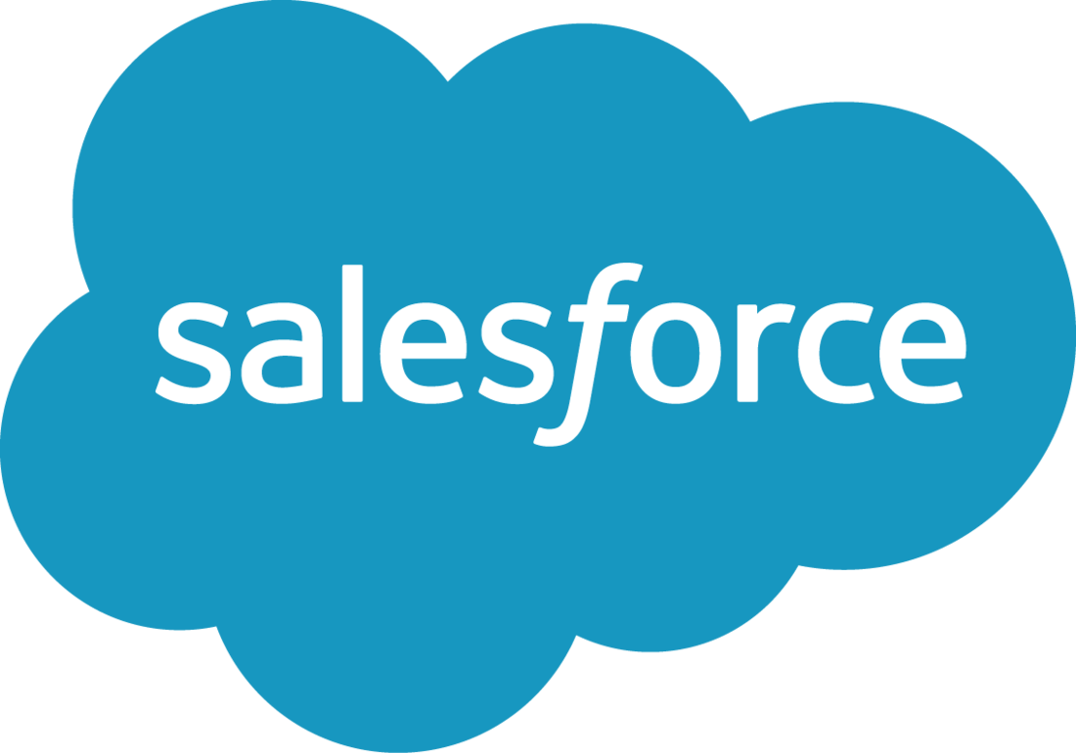

In 2019, Salesforce was named the best worldwide CRM provider for the sixth year in a row based on a market share compiled by the International Data Corporation. Some notable facts about Salesforce:

* Salesforce has approximately **150,000** separate businesses as customers.
* Within these businesses, estimates say there are around **3.75 million** individual subscribers to Salesforce.

Why exactly is Salesforce so popular and widely used?

A big reason is that Salesforce is an incredibly customizable and flexible platform that integrates with many other types of business software. No matter what a company does, which department needs CRM software, what the size of the company is, or how long the company has existed, Salesforce is a good CRM option.

Why is this important for you?

In this certificate, you will be learning the skills to be a sales operations specialist. This job is focused on leveraging the tools in Salesforce to best meet the needs of a company and help sales teams (and sometimes marketing and customer service teams) do their jobs more efficiently and effectively.

The better your Salesforce skills, the more value you will bring to an organization as a problem solver, process builder, and critical thinker.

Who Uses Salesforce?

As you now know, CRM systems are robust tools that are used across many teams in businesses. Next, you will learn more about how different business functions use CRM systems like Salesforce in their workflows. Remember, the more you understand the functions of these different roles, the more you will be able to support and empower them as a sales ops specialist.

**Who Uses Salesforce**

[MUSIC] Salesforce's used by teams of all sorts, including sales teams, marketing teams, customer service teams, supply chain teams and HR teams.

**Sales teams use Salesforce to track potential customers,** customers that air in the process of making a purchase and customers that have previously purchased from the company, as well as how well certain employees projects where efforts are performing. All this allows sales seems to focus on making sales rather than on staying organized.

**Selani, a sales manager, uses the Salesforce products sales cloud with her team.** She can see which companies each of her sales reps is speaking to and how many of these conversations lead to completed sales. This allows Selani to track the overall success of the team problem solved when challenges arise and reward her employees for their success when sales are made.

Play video starting at ::52 and follow transcript0:52

**Marketing teams use** Salesforce to check how people have responded to pass marketing efforts, predict what efforts will perform well and accomplish goals in the future, and create marketing material that is statistically more likely to perform well. Dean is a marketing lead for a company that does most of its marketing online. Different members of his marketing team are responsible for different online marketing locations went for Social Media, one for email marketing and so on.

**The team uses the Salesforce Product Marketing cloud t**o track the performance of all their efforts. As the marketing lead, Dean is able to see all this information and then alter and improved marketing efforts that are failing by comparing them the efforts that are successful.

Play video starting at :1:31 and follow transcript1:31

Customer service teams use Salesforce to track what interactions and conversations have taken place with Each customer responds to a customer's needs with the context of past problems they faced and make customers feel valued and known through personalized support. Tyler is a customer service rep in charge of responding to online messages his store has received from customers who were having a problem with an item they purchased **through the Salesforce product service Cloud**. Tyler can look up the customer he is interacting with to see their information, including the customer's purchase history and past customer service needs. This way, Tyler can know exactly what product a customer is talking about and how to best help them supply chain teams use salesforce to track meetings with vendors who supply them products and to track the movement of these products themselves by using story notes. This hope supply chain teams work more efficiently, since there are lots of moving parts and changing needs on any given day each day.

Jen, a supply chain manager, needs to make sure that all the parts are company has ordered are on their way and are being sent to the correct locations. She uses Salesforce to track what parts have been ordered, what suppliers they were ordered from and when they arrive. Jen also uses sales force to ensure that the customers who have ordered products from her company are receiving the correct shipments and receiving them on time. This helps to ensure the full supply chain system functions smoothly.

Play video starting at :2:54 and follow transcript2:54

Human Resources Teams use salesforce to improve the process of hiring new employees and keep track of employees processes for current staff. Having all this information in one place allows an HR team to more accurately assess what current staff needs exists and directly compare these needs to new hires and potential candidates. Rachel is an HR specialist in charge of finding new hires. She uses salesforce to keep track of all applicants, scan for applicants that fit the needs of the program and track communication with those applicants. Rachel also uses Salesforce to keep track of requests that her staffing clients have made about new employees so that she can take those wants into consideration during the interview process.

Play video starting at :3:34 and follow transcript3:34

These are all examples of teams effectively using Salesforce in different ways to track all the relevant data and make their workflow more efficient. In actuality, not every team leverages salesforce properly. As a sales ops specialist, it will be your job to help them get to this place of efficiency.

**Question**

Which of the following do you think is a strategy a sales manager could use to enhance the performance of her sales team?

Track and forecast sales team performance using reports and dashboards in Salesforce.

Correct

Yes! As you will see later in this certificate, reports and dashboards are a great way for a sales manager to track and forecast sales team performance. The more visibility a sales manager has into team performance, the easier it will be for them to determine which metrics they should focus on to enhance sales.

Question

What is the name of the Salesforce product that teams can use to ensure customer satisfaction and success?



The Service Cloud

**Correct**

Yes! The Salesforce Service Cloud includes a suite of tools that enables teams to handle all customer service issues.

**The Flexibility of Salesforce**

While you now understand how different types of employees use Salesforce, it is important to note that every employee and every workplace will use Salesforce a little differently. Even if two companies both have a marketing team, it is possible that they use Salesforce within their marketing teams in completely different ways.

In this course we will generally refer to Salesforce as a system used to track and maintain customer relationships, but keep in mind that the uses for this system are almost limitless. This is the great part about learning to use and configure Salesforce: almost any business, non-profit, or organization can benefit from using Salesforce's many products to simplify their internal processes, making anyone who is familiar with Salesforce highly employable. This makes **anyone with a robust Salesforce skillset** extremely important, since businesses need them to properly configure Salesforce for the business or organization's particular needs.

**What Types of Businesses Use Salesforce?**

As you have just learned, Salesforce can be used flexibly across many roles and business teams. However, Salesforce is not only flexible within workplace roles, but across different company types and structures as well.

For instance, one example of Salesforce use could be a country-wide real estate company using the platform to keep track of potential customers who are looking to buy a house in each region. This company could then use the platform to reach out to these customers and help them make a purchase.

For another very different example, imagine a small public high school using Salesforce. Public high schools don't necessarily reach out to clients or try to make sales the way a large business does. However, a public high school could use Salesforce to keep track of enrolled students, what grade these students are in, and emergency contact information for the students.

In both cases, the Salesforce platform works to organize information and improve the efficiency and function of the organization, as well as their relationships with the individuals or businesses they work with.

**Look at the table below to learn how Salesforce can be used across a variety of businesses:**

| **Industry** | **Use Case** |
| --- | --- |
| Healthcare | Solutions for personalized, connected, and responsive care. |
| Government | Connecting citizens, agencies, and processes in the cloud. |
| Higher Education | Using social, mobile, and cloud to become a connected campus. |
| Manufacturing | Mobilizing sales teams, simplifying order management, and integrating external systems. |

As you can see, Salesforce applies to almost any type of organization, group, or business. This means that professionals who have a deep understanding of Salesforce are essential employees in today's job market. These valuable skills are what you will be learning in this course and throughout this professional certificate.

**Flexibility of Salesforce**

**TOTAL POINTS 3**

1.

Question 1

What is the name of the Salesforce product that can be used to track potential customers, customers who are in the process of making a purchase, and customers who have previously purchased from a company?

**1 / 1 point**



Sales Cloud

**Correct**

Yes! Sales Cloud can be used to track customers throughout all steps of the sales funnel.

2.

Question 2

What is the name of the Salesforce product that can be used to track responses to past marketing efforts, predict which efforts will perform well in the future, and create marketing material that is statistically more likely to perform well?

**1 / 1 point**



Marketing Cloud

**Correct**

Yes! Marketing Cloud can be used to meet the needs of the Marketing team, such as tracking the success of marketing campaigns, predicting what will likely perform well and help to accomplish goals in the future, and even create marketing materials.

3.

Question 3

List at least three examples of business types or industries that might use Salesforce.

**1 / 1 point**

Healthcare Government Higher Education Manufacturing

**Correct**

Answers may vary, as Salesforce can be used in almost any type of organization, group, or business. Some examples of industries that were mentioned in this module are:

* Real estate
* Public schools (such as a high school)
* Healthcare
* Government
* Higher Education
* Manufacturing

Intro to Salesforce Essentials

Next, you are going to watch a video that the folks at Salesforce put together to explain a bit more about how Salesforce functions as a CRM platform.

This "Salesforce Essentials" video will introduce some terms that might be new for you, but rest assured — you will hear them again and again throughout this certificate because they are critical to the way that CRM data is stored and organized in Salesforce.

Specifically, you will be introduced to the following Salesforce terms, or objects as you will come to know them:

Leads

Opportunities

Accounts

Contacts

Cases

Don't worry, you don’t need to memorize how all these things function in Salesforce just yet.

You will return to this video — and these concepts — again later in the course. For now though, consider the following video to be an introduction to the core concepts about how Salesforce functions as a CRM.

Salesforce Use Cases

On the Salesforce website, there is a tool that shows how Salesforce can be used for different industries and organizations. [Go to this website and use the tool to explore the diverse use cases of Salesforce](http://www.salesforce.com/solutions/industries/). Pick an industry that you're  interested in and read about how Salesforce is used in this industry. Consider following some of the links included on each industry page to learn more.

Address the following in your discussion response:

1. An interesting fact you learned about Salesforce after exploring the tool linked above.
2. An unexpected use case for Salesforce in the industry you chose to learn more about.
3. Something else you think this industry could do with Salesforce that wasn't mentioned on the website.

Participation is optional

**Week 1 Recap**

Before completing the graded assessment for this week, review the following key takeaways and key terms.

Key Takeaways

**What are CRMs and why are they useful?**

Customer relationship management systems (or CRMs) are centralized tools that help businesses stay connected to customers, keep customer information and contact details up to date, track every customer interaction, and manage customer accounts.

They are designed to help businesses improve customer relationships, streamline processes, and ultimately improve profitability.

**What is Salesforce?**

Salesforce is an incredibly customizable and flexible CRM system that integrates with many other types of business software. Salesforce can be used to improve the workflow of many different business users, including sales, marketing, customer service, supply chain, and human resource teams.

**What types of businesses use Salesforce?**

Salesforce is not only flexible within workplace roles, but across different company types and structures. Some different industries and their use cases include:

* Healthcare: Solutions for personalized, connected, and responsive care.
* Government: Connecting citizens, agencies, and processes in the cloud.
* Higher Education: Using social, mobile, and cloud to become a connected campus.
* Manufacturing: Mobilizing sales teams, simplifying order management, and integrating external systems.

Key Terms

**CRM:**CRM stands for customer relationship management. CRMs are systems that keep customer information in one centralized place.

**Salesforce:** Salesforce is the first company that took CRM to the cloud. That means that companies can access all of their customer information online.

What's Next?

In the next module, you'll learn more about the sales process. But first, make sure you complete the graded assessment for this week.

**Salesforce for Business**

**LATEST SUBMISSION GRADE**

100%

1.

Question 1

True or False: One of the main roles of a sales operations specialist is to leverage Salesforce tools to support and empower sales teams to sell more effectively.

**1 / 1 point**



True

**Correct**

Yes! A sales operations specialist needs to know how to use the tools within Salesforce to help sales teams do their jobs more effectively and efficiently.

2.

Question 2

Which of the following statements is true? Select all that apply.

**1 / 1 point**



Sales operations specialist, sales ops specialist, revenue operations specialist, and even sales representative can all be different names for the same type of job depending on the company you work for.

**Correct**

Yes! Different companies or organizations may have different names for the same type of job.



Different organizations may define the responsibilities of the sales operations specialist role differently.

**Correct**

Yes! Different companies or organizations may define this role differently and may even use different names for the same type of job.

3.

Question 3

True or False: Customer Relationship Management is the process of managing your company’s relationships and interactions with customers and potential customers.

**1 / 1 point**



True



**Correct**

Keeping, organizing, and managing information about your customers and their relationship with your company is an important part of keeping customers happy.

4.

Question 4

True or False? According to the video “What is CRM?” by Zoho, the prime benefits of using CRM are better data organization, enhanced communication, shared information, catching all leads, and knowing your numbers (aka - data).

**1 / 1 point**



True



**Correct**

Yes! These are the five prime benefits of CRM, according to the video.

5.

Question 5

What are some of the benefits of using Salesforce in modern businesses? Select all that apply.

**1 / 1 point**



Salesforce is very flexible.

**Correct**

Yes! No matter what a company does, how big it is, how long it has existed, or which department needs CRM software, Salesforce’s flexibility and customization options make it a good CRM option.





Salesforce integrates with many other types of business software.

**Correct**

Yes! No matter what a company does, how big it is, how long it has existed, or which department needs CRM software, Salesforce’s flexibility and customization options make it a good CRM option.



Salesforce is very customizable.

**Correct**

Yes! No matter what a company does, how big it is, how long it has existed, or which department needs CRM software, Salesforce’s flexibility and customization options make it a good CRM option.

6.

Question 6

True or False: Within a company, Salesforce can be used to support multiple teams, including the sales team, marketing team, customer service team, supply chain team, and/or human resources team.

**1 / 1 point**



True

**Correct**

Yes! Salesforce can be used to support a wide range of teams across businesses and organizations.

7.

Question 7

As a sales operations specialist, in which of the following categories would you typically support a sales team? Select all that apply.

**1 / 1 point**



Strategy

**Correct**

Correct! A sales ops specialist might provide sales forecasting through the use of Salesforce data and offer ideas for how to optimize the sales process.



Technology

**Correct**

Correct! A sales ops specialist might lead the adoption and customization of a CRM like Salesforce as well as other integrations in the sales team’s tech stack.



Operations

**Correct**

Correct! A sales ops specialist might find the best use of the many tools in Salesforce to make sales and support teams’ work more efficient.



Performance

**Correct**

Correct! A sales ops specialist might use reports to leverage Salesforce data to determine how effectively and efficiently the members of a sales team are doing their jobs.

8.

Question 8

What is the name of the Salesforce product that teams can use to track marketing efforts and create marketing materials?

**1 / 1 point**



The Marketing Cloud

**Correct**

Correct! The Marketing Cloud includes a suite of tools that can meet the needs of a marketing team.

9.

Question 9

Which of the following roles typically require foundational Salesforce skills? Select all that apply.

**1 / 1 point**



Sales operations specialist

**Correct**

Correct! These roles all require the foundational Salesforce skills that are taught in this professional certificate.



Salesforce administrator

**Correct**

Correct! These roles all require the foundational Salesforce skills that are taught in this professional certificate.



Salesforce developer

**Correct**

Correct! These roles all require the foundational Salesforce skills that are taught in this professional certificate.



Salesforce business analyst

**Correct**

Correct! These roles all require the foundational Salesforce skills that are taught in this professional certificate.

10.

Question 10

Which of the following are ways in which a customer service team might use Salesforce to improve customer satisfaction? Select all that apply.

**1 / 1 point**



Use data to provide personalized service

**Correct**

Yes! As a Customer Relationship Management tool, Salesforce is an ideal platform for tracking customer purchases, interactions, and other information. When the customer service team has this information at their fingertips, it allows them to provide personalized service, which will likely improve customer satisfaction.



Track a customer’s purchase history

**Correct**

Yes! As a Customer Relationship Management tool, Salesforce is an ideal platform for tracking customer purchases, interactions, and other information. When the customer service team has this information at their fingertips, it allows them to provide personalized service, which will likely improve customer satisfaction.





Track a customer’s past interactions with the service team

**Correct**

Yes! As a Customer Relationship Management tool, Salesforce is an ideal platform for tracking customer purchases, interactions, and other information. When the customer service team has this information at their fingertips, it allows them to provide personalized service, which will likely improve customer satisfaction.

**Welcome to Week 2**

[MUSIC] I want to tell you a story.

Play video starting at ::6 and follow transcript0:06

My first teaching job was at a high school in the South Bronx in New York City. When I first started teaching that first week was super exciting, was brand new to the job, and I was thrilled to be taking on a new challenge. Time flew by I seemed to have endless amounts of energy. And then the second week came. And once the initial excitement of that first week burned off, reality set in, that's when it hit me. There was so much I didn't know about this job and teaching, I realized it's going to be tough.

Play video starting at ::38 and follow transcript0:38

Thankfully, I knew who I was doing this for my student. And I also knew my why, the future state I was moving toward, because I wanted to become the best educator I possibly could. And in order to do that I had to lean into the uncomfortable moments, because I knew there were so many learners. Learning opportunities they're waiting to be discovered. Hello again. I'm Anthony Jones when the learning design team here at pastoring, one of your instructors. Welcome to the second week of sales and CRM overview I told you this last week but it bears repeating. By taking this course you are taking your first steps towards mastering the foundational skills needed in salesforce to start a new career. And that's a pretty amazing thing. This week is all about sales and the sales process. By the end of this week, you'll be able to distinguish between two major types of sales B2C and B2B. Identify each step of the sales process and explain their importance. Explain how the sales process might differ across different companies and distinguish between the different roles on a sales team.

Play video starting at :1:44 and follow transcript1:44

This is critical information not only for the sales ops specialist role but for any entry level sales job, and if during this second week you feel your motivation start to slip a little bit. If all of a sudden you're feeling like this journey is going to be tough. I want to encourage you to look for your who and your why. Who are you doing this professional certificate for and why is that important? What's the future state you're moving toward? Are you imagining yourself in a new role as a sales app specialist, or maybe even as a sales force admin one day, if you want, take a moment to write down your who and why. Believe me, it can help.

Play video starting at :2:24 and follow transcript2:24

If you wrote something down, thank you, even if you just thought about it. That's fine too, because when times get tough you can return to your who and your why, for inspiration. Until I see you again. Happy learning [MUSIC]

Defining your who and your why early in your learning journey can help you create a clear narrative about why you're enrolled in this certificate, and it can also serve as important inspiration during the weeks where you feel your energy start to sag. Take a moment to reflect on the following questions:

**Question**

1) Who are you completing this course and this professional certificate for? Are you doing it primarily for yourself and your own development? Or are you also doing it to make a positive impact on the community you're a part of? Please explain your answer.

2) Why is it important for you to complete this course and this professional certificate? Do you need foundational Salesforce skills to enhance your current role, or do you want to change careers altogether? What job would you like exactly? Where would you like to be six months from now? Please be as detailed as you can. The clearer you can envision the future state you want to move toward, the more likely you are to get there.

**The Sales Process & Why It Matters**

A New Cell Phone

Think about the last time you set up your phone service with your cell phone provider, if you've done so before. Maybe it went something like this:

You see an ad for a phone company with a deal you liked on TV. You are interested to learn more, so you visit the phone company's website and give them a call to discuss their services and offerings. You chat on the phone with a representative to get more details. Maybe you tell them that you'd like more time to decide and shop around. They take down your contact information, and then follow up with you a week later to see if you are still interested. They answer more of your questions and address any concerns you have. You're sold — it seems like a great deal. Then, voilà! They set you up with an account right then and there. Maybe you chat with a customer service representative a couple times after that to get all the details of your phone plan ironed out and set up. But that's it — you have a cell phone, and you couldn't be happier!

This process, which almost everyone has experienced, is a simple example of a business moving a customer through their sales process, from the initial moment of awareness of the business to the final step, making a purchase.

**Why This Matters**

For every purchase that you make, there is a process behind the scenes to make sure that it is easy for you to do so. Companies focus on making sales every day, so there are entire departments, processes, and protocols put in place to make sure that the sale runs smoothly.

One of the main use cases for CRM systems is sales. Before exploring the nitty gritty of how a CRM like Salesforce works, you'll first need to understand a bit about how sales works. In order to fully understand the value and importance of Salesforce — as well as the value a sales operations specialist provides to an organization — it's critical that you first understand a few foundational principles of sales and who makes up a sales team.

**Sales 101: What Are We Selling?**

When you think of working in a sales department, you might think of something like what you see in this video clip from the Pursuit of Happyness.

While this clip from the film The Pursuit of Happyness does capture some aspects of sales (colds calls, tactics, etc.), in reality, sales teams have many different, nuanced jobs and functions, and there are a variety of processes and considerations that are necessary for modern sales teams to perform well.

Now, let's get some definitions down. The term sales captures all activities involved in selling a product or service to a consumer or business. Seems simple enough, but actually, a "sale" can capture a number of different kinds of transactions, depending on the type of business or organization. It's important to understand the different kinds of sales that exist because the way a CRM is used and configured will differ based on what kind of sale is being made.

Take a look at the next video to hear from real employees who work on sales teams at Microsoft to gain some understanding about what their roles entail.

**Different Sales Models**

In this course, we will refer to two major kinds of sales models that businesses use:

B2C (business-to-consumer) sales: The process of selling products or services directly to consumer. An example of a B2C company is Walmart, a discount retail chain, because it sells products directly to consumers.

B2B (business-to-business) sales: The process of selling products or services to other businesses. An example of a B2B company is Hootsuite, a social media management system that helps companies keep track of different social media platforms such as Twitter, Facebook, and Instagram. Hootsuite sells to other businesses.

Read the Forbes article "Differences in Selling B2B vs. B2C" to learn more about the distinctions between these two kinds of sales through several examples.

Next, you will review the similarities and differences between B2C and B2B sales.

Regardless of what they're selling and who they're selling it to, sales teams ultimately care about making sales efficiently and effectively — and your role as a sales operations specialist will be to support and empower them in this effort. Keep in mind that sales teams typically get closer their goals by building relationships, building trust, and offering value in order to sell products and services that solve clients' problems.

**Differences In Selling B2B Vs. B2C**

Suppose, for a moment, that you are a farmer with a large apple orchard. You may have to decide between two possible business models, and you are uncertain about which will benefit you most. You can take your produce to the local farmers’ market, where you will likely sell small batches of your apples to an ever-changing pool of customers, or you can partner with large outlets such as Walmart. While Walmart will buy large quantities of apples (thousands or tens of thousands) from you, the retail giant will require a consistent supply at a fixed cost, as well as delivery at specific times to specific locations.

In other words, you must choose between a B2B and B2C model. If you currently face some version of this question, you may be wondering what the differences are in selling B2B or B2C. For some guidance, read on:

**B2B**

B2B, or business-to-business, is distinct from B2C in a number of ways. These include:

*A longer decision-making process*

If you plan to sell B2B, ensure you are prepared to invest time in cultivating a relationship with your potential buyer. For instance, you may need to formally present your proposal or make multiple telephone calls to more than one person within the company. To return briefly to the above example, Walmart is unlikely to choose an apple supplier on a whim – whoever your prospects may be, persistence will be key to landing them.

*A greater number of involved stakeholders*

As previously discussed, you will often have to speak to multiple decision-makers when pursuing a B2B partnership. If even one person at any step in this process says, “No, thank you,” you must begin again back at square one or with another business. To minimize the likelihood of this occurring, take the time to learn who the key decision-makers are at your potential buyer, and do everything you can to make it easy for them to say, “Yes,” to your pitch.

*A lengthier relationship*

Companies typically seek longer relationships than consumers do. For example, it would be tremendously challenging and costly for Walmart to switch apple suppliers each month or each year. The big box business would rather have a reliable partner that it can depend on for the foreseeable future. Consider McDonald’s – the fast food chain became the single largest purchaser of apples in the United States when it added apple slices to its menu. If McDonald’s regularly changed vendors, it would face the logistical nightmare of having to frequently re-stock over 14,000 stores by jumping from supplier to supplier.

For you, this relationship development means exploring the fine details of a long-term deal *before* you meet with companies. Whenever possible, arrive with your ideal terms in mind, rather than allowing your prospective business customer to dictate them.

*A smaller lead pool*

B2B generally involves a smaller pool of prospects when compared to B2C. For instance, Amazon’s consumer-oriented website has a potential customer pool of millions – in essence, anyone with an Internet connection. In contrast, a B2B company, such as a manufacturer who makes infotainment flat screens for automobiles, might only sell to the limited number of car companies in the world. Chrysler, Ford, GM, Honda, and Toyota collectively make up [70% of the U.S. automobile market](http://www.thetruthaboutcars.com/wp-content/uploads/2014/09/TTAC-USA-auto-brand-market-share-chart-August-2014.png), so if you sell car parts, your target audience will likely be one of these businesses. Your customer pool is inherently more defined, which can have negatives and positives. On one hand, you already know to whom you should tailor your sales pitch. On the other hand, so do your competitors.

*A different type of product knowledge*

A consumer who is deciding between three brands of potato chips in the snacks aisle is likely operating on a different choice system than an executive who needs to select a payment processing solution for his or her company. The second scenario requires deeper technical knowledge, as well as a clear understanding of the product’s components. The executive *must* be able to answer the question, “What am I receiving with this purchase?” When selling under a B2C model, your primary concern might be to immediately and simply explain why your product is better than your competitor’s. Perhaps the color of the potato chip bag or its vibrant typeface captures your customer’s attention. Perhaps it’s the overall design of the packaging. A B2B model, however, will require you to have a thorough understanding of the technical aspects of your product, as well as everything the customer receives when he or she purchases it. Thus, it is a great idea to prepare for questions about technical updates, on-going support, etc.

**B2C**

Many businesses, including my company, Varsity Tutors, operate according to a B2C (or business-to-consumer) framework. This framework differs from B2B in three important ways:

*A shorter decision-making process*

An apple vendor at a farmers’ market will largely sell to customers who make their purchasing decisions in-the-moment. Compared to B2B, there is a relatively shorter decision-making process in B2C sales – the couple that browsed your GoldRush apples today is not likely to call you in a month to say they would like to buy apples from you. As a result, your in-the-moment marketing is crucial. It is critical to catch your customers’ attention and to generate immediate need and desire for your product. Given this fact, aim for a large pool of prospective purchasers, as there will always be a certain percentage of leads that decline.

*A smaller number of involved stakeholders*

Often, you will speak to one person, or perhaps two at most. The individual in front of you is the person you have to convince to buy your product, which requires you to quickly establish an emotional connection with that party.

*A shorter relationship*

B2C purchases are more likely to be one-off transactions or transactions with more limited time frames. The person who bought a half-bushel of apples from you may not return to your stand next week or next season.

Whether you decide to sell your product or service B2B or B2C, you will find that determining your customer’s needs (and meeting those needs) is integral to both models. **It is easy to oversimplify B2B as being about cost and features and** B2C as being about emotion and brand appeal when both depend on building a strong connection between you and your consumer. Your success ultimately lies in your ability to personalize your pitch to that one prospect – company or individual – in your sights.

*Chuck Cohn is the CEO and founder of*[***Varsity Tutors***](http://www.varsitytutors.com/)***.***

**B2C vs. B2B Sales: Differences and Similarities**

[MUSIC] There are two major types of sales, B2C and B2B. B2C or business-to-consumer sales refers to the process of selling products or services directly to consumers. While B2B or business-to-business sales refers to the process of selling products or services to other businesses. For example, a car rental company rents cars to consumers, that's B2C. But a car parts manufacturer sells brakes to large auto companies, and that's B2B.

Play video starting at ::33 and follow transcript0:33

For another example, an apple farmer could engage in B2C sales by selling their apples to consumers in a farmer's market. Or, they could engage in B2B sales by selling a large batch of apples to a restaurant chain. Here are some of the differences in the sales process between B2C and B2B sales types. The key sales purpose of B2C sales is to maximize the transaction value. While the key purpose of B2B sales is to build relationships. In B2C sales, the purchase decision typically comes down to one person, the consumer. In B2B sales, whoever there are probably multiple decision makers at the company that the salesperson might need to interact with.

Play video starting at :1:11 and follow transcript1:11

The sales cycle is shorter in B2C sales and it takes less time for the consumer to make a decision. But the sales process lasts longer for B2B sales and includes an engagement period. Some of the things that those decision makers might need to consider during a possible B2C purchase include the product features, brand appeal, emotional attachment and economic considerations such as affordability. Considerations during a B2B sale might include product features, the relationship with the seller, customer support capabilities and value generation.

Play video starting at :1:44 and follow transcript1:44

And finally, the market size for B2C sales is quite large, while the market size for B2B sales is small and focused. But for all their differences, these two sales types have their similarities as well, both require a customer centric sales process. Both seek to deliver top notch customer service and experience. In both cases, salespeople need to be credible and authentic in order to close deals, and both consider customer loyalty to be of high importance. You now know some of the differences and similarities between B2C and B2B sales types. [MUSIC]

**Question1**

A web development firm that creates websites for businesses is an example of a company engaging in which type of sales?

B2B Sales

**Correct**

Yes! In this case, the web development firm (a business) is selling their website creation services to other business. Therefore, it is engaging in B2B (business to business) sales.

Correct

Answers will vary, but should include elements of the following:

**Similarities between B2C and B2B**

**Correct**

Answers will vary, but should include elements of the following:

* Both require a customer-centric sales process.
* Both require top-notch customer service and experience.
* In both, salespeople need to be credible and authentic to close deals.
* Customer loyalty is of high importance for both types of sales.

**Types of Sales**

TOTAL POINTS 4

Question 1

What is the most accurate definition of “sales”?

All of the activities involved in selling a product or service to a consumer or business.

Correct

Yes! Depending on the type of business or organization, a “sale” can capture a number of different kinds of transactions or activities.

Question 2

A chemical company engages a software vendor to upgrade its analytics system. What type of company is the software vendor?

B2B

Correct

Yes! The software vendor is B2B because they sell their software to other businesses, like the chemical company.

Question 3

A freelance digital marketer buys a pair of headphones online from a popular electronics brand. What type of company is the electronics brand?

B2C

Correct

Yes! The electronics brand is a B2C company because they sell their products, like headphones, to consumers rather than to businesses.

Question 4

A popular footwear company sells shoes to individuals out of their online and mall stores. They also sell large custom design sneaker orders to businesses and company teams. What type of company is the footwear company? Select all that apply.

1 / 1 point

B2C

Correct

The footwear company is B2C because they sell to individual consumers as well as B2B because they also sell to businesses.

B2B

Correct

The footwear company is B2B because they sell to businesses, and it is also B2C because they sell to individual customers as well.

**An Organized Approach to Selling**

After reading the Forbes article and reviewing the graphic organizer on B2C vs B2B sales, you may have observed that sales is a process that takes time, effort, repeated touch points, and sometimes buy-in from multiple stakeholders (especially in B2B) in order to close just a single sales deal. That's a lot to keep track of! In fact, because it's such a complex and important process, most companies actually have a dedicated sales process, or set of repeatable steps that a salesperson can take to bring a prospective customer from the initial stages of awareness of a product or service to a closed sale. Every company organizes and completes the sales process a little differently. As a sales ops specialist, a big part of your job will be to help optimize this process. In this course, we will present one iteration of the sales process; companies that you work for in the future may have variations on this process — regardless of these differences, the fundamental Salesforce skills you learn in this certificate will provide you with techniques for optimization.

In this lesson, you'll begin to familiarize yourself with the sales process. You'll need to understand this important framework in order to fully grasp how to use CRM to support a sales team during this process because CRMs like Salesforce's Sales Cloud are built with the sales process in mind.

**What is the Sales Process?**

Watch this 60-second video by Nutshell for a quick overview of the sales process. Don't worry if there are a few terms in there that you're not yet familiar with — we will define them soon.

As you'll learn from the video, the sales process is an organized, multi-stage, organized approach to closing sales. It provides sales teams with a playbook, or a general formula, for how they should go about making sales for their company. Let's meet a few characters who will help us make sense of the sales process in greater detail.

Meet the Team

As you go through this course, this cast of characters will help to illustrate the sales process. As a sales operations specialist, this is the team you will be supporting and empowering on the job. Throughout this certificate, you will use Salesforce to enable them to do their jobs as effectively and efficiently as possible!

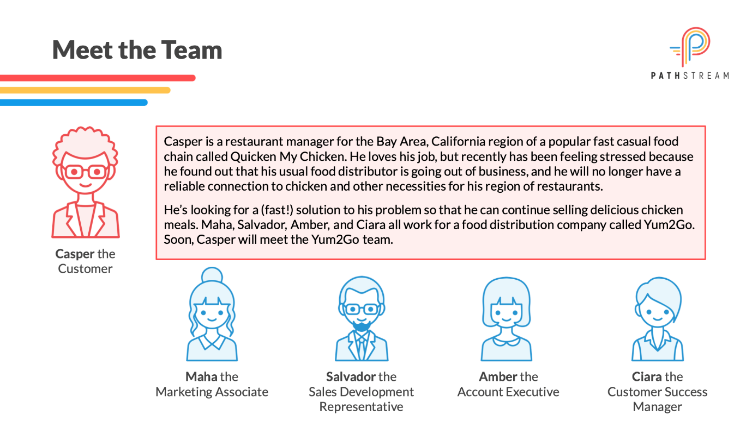

For now though, focus on getting to know them a little bit better and how they fit into each part of the sales process. The better you know them and what their roles entail, the better you will be at your job.

Meet the Team: Casper is the customer who enjoys visiting a local chain called Quicken My ChickenMeet the Team: Casper is the customer who enjoys visiting a local chain called Quicken My Chicken, Maha is the Marketing Associate, Salvador is the Sales Representative, Amber is the Account Executive, and Ciara is the Customer Success Manager

**The Typical Stages of the Sales Process**

Remember, the sales process is a set of repeatable steps that a sales team can take to bring a prospective customer from the initial stages of awareness of a product or service to a closed sale.

The sales process provides sales teams with a structured roadmap to efficiently and effectively close deals. Each company’s sales process will differ based on their business, industry, market, and product/service. In this course, we will mostly discuss B2B sales processes, which tend to be longer and more involved. Below is a typical step-by-step B2B sales process.

A B2B chain starting with Prospecting and then Qualifying, Presenting, Closing and ending with Customer Success

processes, which tend to be longer and more involved. Below is a typical step-by-step B2B sales process.



Let's break this process down in the following lessons.

**Stage 1: Prospecting**

To sell anything, you first need customers to whom you’d like to sell. So, let’s start with leads. As you might remember, a lead is an individual or organization with an expressed interest in what you are selling. A lead is simply another way of referring to an interested or potentially interested customer. Prospecting, sometimes referred to as lead generation, is the process of identifying potential customers.

Leads can be generated either by a marketing or sales department, or even both, depending on the company. There are two types of leads: inbound and outbound.

Inbound leads are leads that come directly to a business and express their interest. An inbound lead might express interest in a company through behaviors like visiting the company’s website and downloading an eBook from them, subscribing to their blog, or signing up for more information. All of these activities provide the business with the lead's contact information.

Outbound leads are leads that businesses seek out and reach out to in order to sell to them. This is often done through cold calling. Businesses can also buy “lead lists” which are simply lists of leads and their contact information that are sold by third parties.

Recommended Reading

Check out these optional, additional resources if you'd like to learn more about this stage of the sales process.

We will refer to lead generation and prospecting as the same thing. However, some experts argue that lead generation and prospecting are similar but distinct processes.

If you'd like to learn more about how businesses generate leads, check out this guide by hubspot [Lead Generation: A Beginner's Guide to Generating Business Leads the Inbound Way](https://blog.hubspot.com/marketing/beginner-inbound-lead-generation-guide-ht) If you have any difficulty viewing the following image, you can also download the complete sales process example by clicking the PDF below.

**Sales\_Process\_Example.pdf**PDF File

**Welcome to Week 4**

Hey, everybody, Anthony here. Quick question for you, imagine you just signed up to run a marathon, what do you think would be the hardest part of the race for you? For many people, just getting started with something big like a marathon would be the hardest part, for others, their energy might sag a little in the middle once they're actually running the race. And then there are some who find the last stretch actually summoning the energy needed to get to the finish line to be the most challenging. Welcome to week four, the final week of sales and CRM overview. You've done a great job making it this far, so first of all, take a moment to appreciate your effort. Taking steps towards mastering the foundational skills needed in Salesforce to start a new career isn't easy stuff, so congrats on making it to this point. But there's still work to be done, so let's stay focused and make sure we finish strong. This week, you will have the chance to enter Trailhead, Salesforce official learning platform, enabling you to navigate and explore some of the features of the Salesforce SalesCloud. By the end of this week, you will be able to create and set up a Trailhead account, identify key components of the Trailhead learning experience, set up a Trailhead playground and describe the key functionalities of the SalesCloud CRM that helps support a business's growth. The finish line for this course is in sight, let's run through it. Until I talk to you again, happy learning. [MUSIC]

Salesforce & Why It Matters

As you know now, Salesforce offers a powerful set of tools that helps businesses connect to their customers.

Take a moment to review the advantages of Salesforce by reading about Jane, a small business owner, who learned how to make Salesforce work for her business needs.

Jane runs a small pottery business and takes on all of the sales and marketing responsibilities. For 20 years, she has sold her beautiful, handcrafted goods directly to individual consumers, restaurants, and craft stores. To keep track of information about her customers and marketing campaigns, she archives emails, captures notes in a spreadsheet, collects business cards, and jots down info on sticky notes. Jane has a hard time keeping track of important data and lacks a complete picture of each one of her customers, since she keeps information in multiple places.

**Organizing Customer Information Without Salesforce**

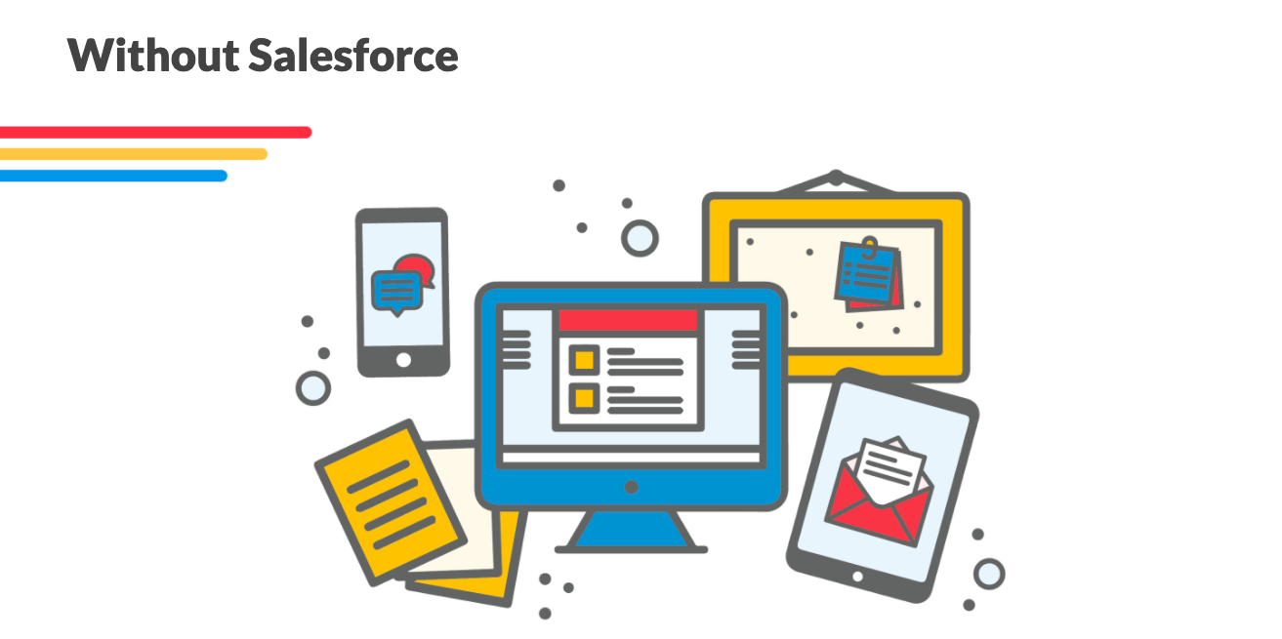

Jane finds out about Salesforce from a friend. She learns that by using Salesforce, she can consolidate all the different information for each of her customers and marketing campaigns. With Salesforce, she can easily track customer orders, calls, and even data like birthdays so she can maintain a personal relationship with her customers.

Because Jane is in charge of all of her business's sales and marketing functions, it is important that she feels comfortable with Salesforce, otherwise it is not useful to her. She benefits from using **Trailhead**, which is Salesforce's online library of free educational resources. It helps her learn all the skills she needs to make Salesforce work best for her.



Why This Matters

Whether your goal in taking this course is to learn to use Salesforce for your current job, to build the skills you need for a job as a sales operations specialist, or to prepare for something more advanced like the Salesforce Administrator Certification Exam, Trailhead will be an incredibly important resource for you because it will help you continuously learn and grow with Salesforce.

Remember, Salesforce is a tool that is continuously evolving and changing to best meet users' needs. As someone who works with Salesforce professionally, it's important that you keep track of the latest releases and continue mastering your new skills with this ever-changing platform.

In this module, you will get comfortable with Trailhead, an important resource to help you continuously build your knowledge about Salesforce. You will use Trailhead throughout this course and certificate to practice hands-on with the software.

Trailhead Overview

By now, you know that Salesforce has powerful tools that you — as a sales operations specialist — can leverage to enable sales teams to better connect with customers, partners, and potential customers.

Before you start diving into the specifics of these different tools, however, you'll need to familiarize yourself with a very helpful learning resource: Trailhead. Trailhead is Salesforce's library of free educational resources made for everyone from Salesforce novices to experts.

Trailhead Logo

Trailhead icon

At times throughout the remainder of this course and professional certificate, you will learn new skills through Trailhead's learning resources. Sometimes, you will be instructed to follow a link to Trailhead content and then return to Coursera in order to master specific material. Think of Trailhead and Coursera as complementary learning experiences as you complete this certificate.

Trailhead organizes learning into modules, or discrete learning experiences focused around specific topics related to Salesforce, which are then further organized into smaller learning experiences called units. Note that Trailhead modules are different from Coursera modules.

Once you have a Trailhead account, you will see the many modules available to you as a learner. The following image is an example of modules you might find on the Trailhead landing page. In the following image, "Trailhead Playground Management" is an example of a module.

Modules on Trailhead's Website

Trailhead website module with the "Trailhead Playground Management" tab highlighted with a red box.

The following image is an example of the units you might find within a module. In this example, "Create a Trailhead Playground" is a unit within the Trailhead module "Trailhead Playground Management."

Units in a Module on Trailhead

Now it's time to create your Trailhead account! Continue on to learn how to do this.

**Time Estimate**

 About **5** mins

**Topics**

* [Learning Objectives](https://trailhead.salesforce.com/en/content/learn/modules/trailhead_basics/get-started-with-trailhead#learning-objectives)
* [Welcome to Trailhead and the Trailblazer Community](https://trailhead.salesforce.com/en/content/learn/modules/trailhead_basics/get-started-with-trailhead#welcome-to-trailhead-and-the-trailblazer-community)
* [How Does It Work?](https://trailhead.salesforce.com/en/content/learn/modules/trailhead_basics/get-started-with-trailhead#how-does-it-work)
* [Who Are Trailhead and the Trailblazer Community For?](https://trailhead.salesforce.com/en/content/learn/modules/trailhead_basics/get-started-with-trailhead#who-are-trailhead-and-the-trailblazer-community-for)
* [What Makes Trailhead Special?](https://trailhead.salesforce.com/en/content/learn/modules/trailhead_basics/get-started-with-trailhead#what-makes-trailhead-special)
* [Where Do I Start?](https://trailhead.salesforce.com/en/content/learn/modules/trailhead_basics/get-started-with-trailhead#where-do-i-start)
* [Who, Me?](https://trailhead.salesforce.com/en/content/learn/modules/trailhead_basics/get-started-with-trailhead#who-me)
* [What’s a Hands-on Challenge, Anyway?](https://trailhead.salesforce.com/en/content/learn/modules/trailhead_basics/get-started-with-trailhead#whats-a-hands-on-challenge-anyway)
* [What’s a Trailhead Playground?](https://trailhead.salesforce.com/en/content/learn/modules/trailhead_basics/get-started-with-trailhead#whats-a-trailhead-playground)
* [What’s Next?](https://trailhead.salesforce.com/en/content/learn/modules/trailhead_basics/get-started-with-trailhead#whats-next)
* [Resources](https://trailhead.salesforce.com/en/content/learn/modules/trailhead_basics/get-started-with-trailhead#resources)
* [Challenge**+100 points**](https://trailhead.salesforce.com/en/content/learn/modules/trailhead_basics/get-started-with-trailhead#challenge)

[**Question, feedback or help**](https://trailhead.salesforce.com/en/help)

Get Started with Trailhead and Trailblazer Community

**Learning Objectives**

After completing this unit, you’ll be able to:

* Explain what Trailhead is and who it’s for.
* Explain what the Trailblazer Community is and who it’s for.
* Create your Trailblazer identity.

**Welcome to Trailhead and the Trailblazer Community**

Every journey starts with a single step—and so does every trail. You’ve already taken the first step of your Trailblazer journey by joining us here on Trailhead.

At the heart of Trailhead and the Trailblazer Community is you—our Trailblazer. A trailblazer is:

* A pioneer; an innovator; a lifelong learner; a mover and shaker.
* A leader who leaves a path for others to follow.
* Most importantly, a person who builds a better world for others.

Trailhead and the Trailblazer Community are part of one unified platform. The Trailblazer Community helps you learn relevant skills, connect with other Trailblazers, and give back. Together, Trailhead and the Trailblazer Community are your one-stop shop to learn, earn, and connect from anywhere. Whether you’re an admin just starting out, a graduate fresh from college, a Salesforce user, or just someone who loves to learn, there’s something on Trailhead for you.



**How Does It Work?**

In Trailhead, learning topics are organized into modules, which are broken up into units. To finish a unit, you earn points by completing a quiz or a challenge. A quiz checks your knowledge with multiple-choice questions, while a challenge tests your skills by getting your hands dirty in a Salesforce org. Once you’ve finished all of the units in a module, you get a shiny new badge for your profile.

Trails are groups of modules that provide guided learning paths suited to specific roles or needs. You can also blaze your own trail, and choose the modules that you’re most interested in without following a pre-existing trail. Projects and superbadges allow you to learn interactively by requiring you to implement a feature or solution in an org.

The Trailblazer Community is where you connect with other Trailblazers. You can expand your network in the Trailblazer Community by joining groups both online and in-person. And you can learn more about specific subjects with topics. Discover and follow featured topics, tag your questions with topics to get a conversation started, and get answers from Trailblazers around the world. You can also follow Trailblazers who inspire you or who share common interests. When you follow a Trailblazer, follow a topic, or join a group, you’ll see updates in your feed.

You just learned a lot of terms in just a few paragraphs. If it seems like a lot to keep straight, don’t worry. Let us be your trail guide, and work through the rest of this module to learn the ins and outs of our platform.

**Who Are Trailhead and the Trailblazer Community For?**

We have content for every role within an org, and every level of experience. Come to Trailhead and the Trailblazer Community to learn, earn, and connect, whether you’re a representative using Service Cloud, a Salesforce solution architect, or an aspiring Salesforce professional. We even have material for learning outside of Salesforce, such as modules on [Blockchain Basics](https://trailhead.salesforce.com/content/learn/modules/blockchain-basics" \t "_blank) and [European Union Privacy Law Basics](https://trailhead.salesforce.com/modules/european-union-privacy-law-basics), and a trail to help you [Get Started with iOS App Development](https://trailhead.salesforce.com/content/learn/trails/start-ios-appdev).

As a member of the Trailblazer Community you can join groups, where you can discuss different subjects with a group of Trailblazers. Some groups are role-, product-, or solution-based, while others are interest- or region-based (like the Salesforce Certified Professionals group or Hyderabad Community Group).

You can also participate in—or start—a discussion around topics in the Trailblazer Community. A topic allows any Trailblazer to discuss or ask about a specific Salesforce subject, like #Service Cloud, #Mobile Development, or #MyTrailblazerStory.

And because we know that you’re blazing trails all over the world, Trailhead and the Trailblazer Community are available in six languages: English, German, Japanese, French, Latin American Spanish, and Brazilian Portuguese. To change to another language, scroll down to the footer of any page and choose a language from the dropdown menu.

**What Makes Trailhead Special?**

Trailhead content blends a variety of content types and approaches to cater to all types of learners, including:

* Videos
* Code samples
* Walkthroughs
* Screenshots
* Images
* Tables and charts
* Step-by-step instructions

When we create content, we use a set of guiding principles that include:

* Practical examples and scenarios
* Storytelling
* Authenticity
* Casual voice and tone
* Positivity
* Fun
* Fun
* Fun

And did we mention fun? We want you—and everyone who uses Trailhead and the Trailblazer Community—to have fun together. We gamify our content so that you can learn new skills while you earn points and badges. And we connect you with local Trailblazers just like you so that you can learn together in person.

**Where Do I Start?**

First things first: To complete challenges, earn badges, connect with Trailblazers, and keep track of your progress, you need to create an account. To create an account, click **Sign Up** from anywhere in Trailhead.

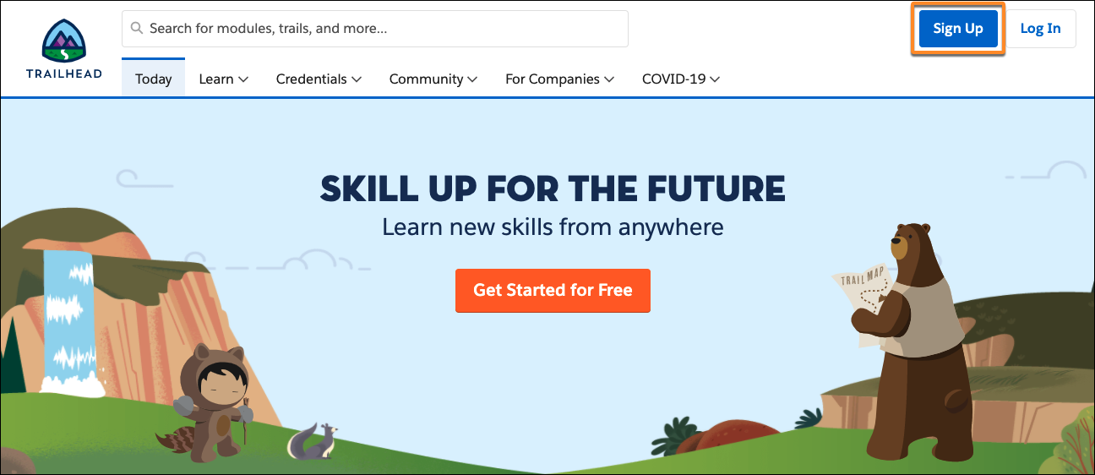

You have a few options. You can sign up for Trailhead and the Trailblazer Community with Salesforce, Google, LinkedIn, or your email address.

Choose whatever is easiest for you. We use your identity for login purposes only, and each option has its benefits. If you choose a social identity, you can keep your Trailblazer.me profile no matter where your career takes you. If you choose your company Salesforce login, your company can use the Trail Tracker app to see all the awesome learning you’re doing. If you want to connect both identities or modify them after signup, you can do so anytime from the settings page on your profile.

To link your social accounts to an existing Trailblazer identity, click your profile image in Trailhead and then click **Settings**. Scroll down and click **Connect** to connect your Salesforce, email, or social account, respectively. If the login identity you’re trying to link already has Trailhead or Trailblazer Community data, such as badges, points, groups, connections, or favorites associated with it, you can merge it with your other account.

**Who, Me?**

Your Trailblazer.me profile is your digital Salesforce resume, showing colleagues and employers your achievements and connections. You can personalize your profile URL when you sign up, making it easy to share your Traillblazer.me profile anywhere, with anyone. You use this single identity to log in to and interact with Trailhead, the Trailblazer Community, Salesforce IdeaExchange, Salesforce AppExchange, and more.

**What’s a Hands-on Challenge, Anyway?**

Learning is the bread and butter of Trailhead, and one of the best ways to learn is by doing. Earning a badge on Trailhead is more than just reading through modules. You also have to complete either a multiple-choice quiz or a hands-on challenge at the end of each unit. You’re probably familiar with multiple-choice quizzes, but hands-on challenges are unique to Trailhead.

A hands-on challenge is more involved than a quiz and, as a result, earns you more points. To complete a hands-on challenge, you have to look at a set of requirements and do something in a Salesforce org to meet those requirements. What you have to do depends on what you’re learning. You could be writing an Apex class, creating a Lightning web component, or writing a field-level validation formula.

We even provide you with your own org, called a Trailhead Playground, that you can use to solve hands-on challenges.

**What’s a Trailhead Playground?**

When you encounter your first hands-on challenge, you’ll be able to launch your Trailhead Playground. A Trailhead Playground is an org that you can use for hands-on challenges, learning new features, and testing customizations. If you haven’t created one, don’t worry. You get one automatically when you create your Trailblazer.me account.

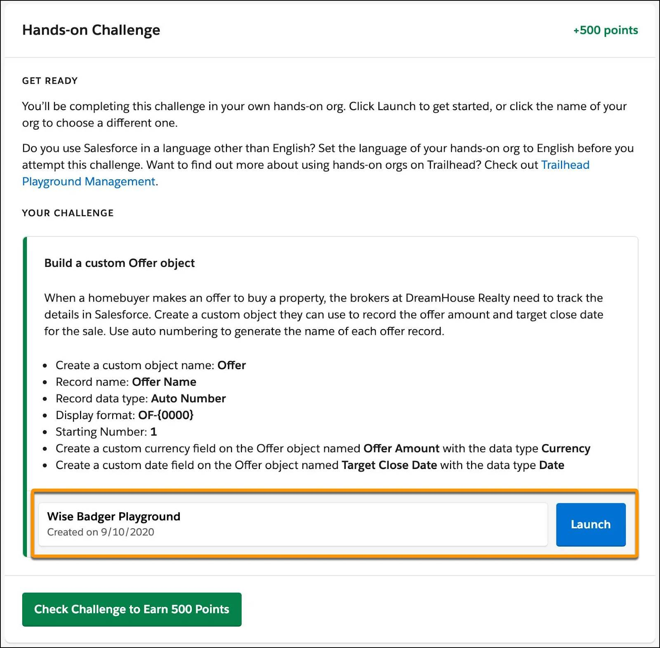

You can customize your Trailhead Playground however you want, and it comes with a set of Trailhead-specific data that you can use when completing challenges. Although Trailhead Playgrounds have limits (you can create only two users in a Trailhead Playground, for instance), they give you the same customization options as a production org. And a Trailhead Playground never expires, as long as you keep using it.

To learn more about creating a Trailhead Playground, see [Trailhead Playground Management](https://trailhead.salesforce.com/trails/learn_salesforce_with_trailhead/modules/trailhead_playground_management).

**What’s Next?**

You’ve signed up for Trailhead and you’re ready to learn. You’re staring into a near-limitless expanse of learning opportunities, and it’s easy to be overwhelmed by the possibilities.

In the next unit, you learn how to navigate your way around Trailhead and the Trailblazer Community and discover the content that’s right for you.

**Resources**

* [*Trailhead:* Trailhead Playground Management](https://trailhead.salesforce.com/trails/learn_salesforce_with_trailhead/modules/trailhead_playground_management)

**Time Estimate**

 About **5** mins

**Topics**

* [Learning Objectives](https://trailhead.salesforce.com/content/learn/modules/trailhead_basics/find-your-way-around-trailhead#learning-objectives)
* [What’s a Trail?](https://trailhead.salesforce.com/content/learn/modules/trailhead_basics/find-your-way-around-trailhead#whats-a-trail)
* [What’s a Badge?](https://trailhead.salesforce.com/content/learn/modules/trailhead_basics/find-your-way-around-trailhead#whats-a-badge)
* [What Are Ranks?](https://trailhead.salesforce.com/content/learn/modules/trailhead_basics/find-your-way-around-trailhead#what-are-ranks-nbsp)
* [What’s a Credential?](https://trailhead.salesforce.com/content/learn/modules/trailhead_basics/find-your-way-around-trailhead#whats-a-credential)
* [Mix Things Up with Trailmixes](https://trailhead.salesforce.com/content/learn/modules/trailhead_basics/find-your-way-around-trailhead#mix-things-up-with-trailmixes)
* [What’s the Today Page?](https://trailhead.salesforce.com/content/learn/modules/trailhead_basics/find-your-way-around-trailhead#whats-the-today-page-nbsp)
* [What’s the Trailblazer Community Feed?](https://trailhead.salesforce.com/content/learn/modules/trailhead_basics/find-your-way-around-trailhead#whats-the-trailblazer-community-feed)
* [What’s a Topic?](https://trailhead.salesforce.com/content/learn/modules/trailhead_basics/find-your-way-around-trailhead#whats-a-topic)
* [What’s a Group?](https://trailhead.salesforce.com/content/learn/modules/trailhead_basics/find-your-way-around-trailhead#whats-a-group)
* [Challenge**+100 points**](https://trailhead.salesforce.com/content/learn/modules/trailhead_basics/find-your-way-around-trailhead#challenge)

[**Question, feedback or help**](https://trailhead.salesforce.com/en/help)

Find Your Way Around

**Learning Objectives**

After completing this unit, you’ll be able to:

* Explain the difference between a module and a project.
* Explain the difference between a topic and a group.
* Explain how you earn points, badges, and ranks.
* Navigate Trailhead and the Trailblazer Community.

**What’s a Trail?**

The essence of Trailhead is, you guessed it, trails. A trail is an ordered group of modules, projects, or both that provides a guided learning path to learning a new skill, product, or role. Because there are so many things you can learn on Trailhead, there are lots of trails—currently more than 200—covering a wide range of topics.

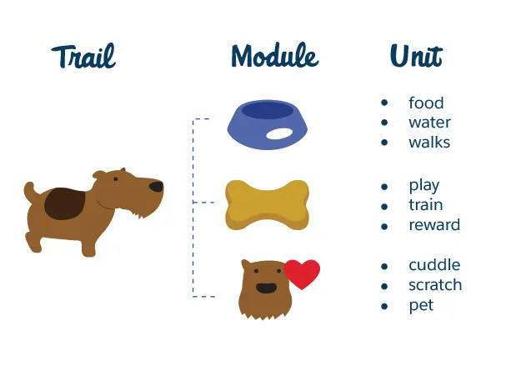

**What’s a Badge?**

There are two types of badges: Modules and projects. A module covers a specific subject, whether it’s a product, skill, feature, or role. While trails are great for comprehensive learning over an entire subject area, you can also mix and match badges freely. Say that you’re a Salesforce developer with 5 years of experience, and your org is about to begin the move to Lightning Experience. It’s not worth your time to work through the entire [Developer Intermediate](https://trailhead.salesforce.com/trails/force_com_dev_intermediate) or even [Develop for Lightning Experience](https://trailhead.salesforce.com/trails/lex_dev) trail—you know most of that stuff already. Instead, you can pick and choose the badges that address the gaps in your knowledge, such as [Lightning Web Components for Aura Developers](https://trailhead.salesforce.com/content/learn/modules/lightning-web-components-for-aura-developers) and [Salesforce Flow](https://trailhead.salesforce.com/content/learn/modules/business_process_automation).

A module is broken down into units. Each unit covers a subtopic within a module and has either a hands-on challenge or a quiz at the end. When you ace the quiz or complete the challenge, you get a healthy dose of points that add to the total displayed on your profile. When you’ve completed all of the units in a module, you earn a new badge.

A project is a series of hands-on steps that lets you learn Salesforce skills by putting them into practice right away. As opposed to a hands-on challenge, which gives you a set of requirements that you have to figure out how to meet, a project lays out step-by-step instructions for you to follow, then validates that you did everything correctly.

To see the full list of modules or projects, hover over the **Learn** tab and click **Modules** or **Projects**, respectively.

**What Are Ranks?**

When you earn points and badges, you advance ranks. When you begin you’re a Scout, and once you’ve earned your first badge you’re a Hiker. Eventually, you could even be an Expeditioner (50 badges and 35,000 points) or a Ranger (100 badges and 50,000 points).

You get more points for completing a hands-on challenge than you do for a multiple-choice quiz, to reflect the extra effort involved. As a result, you need points and badges to earn ranks. To keep climbing, you can’t just stick to modules with multiple-choice quizzes—you need to also complete hands-on challenges. The more points you get, the more badges you earn, and the more quickly you earn ranks.

**What’s a Credential?**

There are two types of credential: Salesforce certifications and superbadges.

You earn a certification by taking a proctored exam that tests your skills. Salesforce certifications are world-class credentials that demonstrate your abilities to work with Salesforce technology. If you’re already certified, Trailhead is where you earn certification maintenance badges, which ensure that you’re up to date on the newest Salesforce features.

The credentials tab gives you more information about the different types of Salesforce certifications, including information about exams, links to sign up for instructor-led trainings, and details about what it means to be a Salesforce professional.

You earn a superbadge by working hands-on in a Trailhead Playground, like you would to earn a module or project. Unlike modules and projects—which focus on a specific topic—superbadges help you learn across an entire feature area by providing a real-life business scenario for which you have to build a solution.

Superbadges are grouped together into super sets to better help you prepare for specific certifications. Each superset is tied to a specific certification and is designed specifically to make sure you have the right skills and knowledge you need to ace the certification exam.

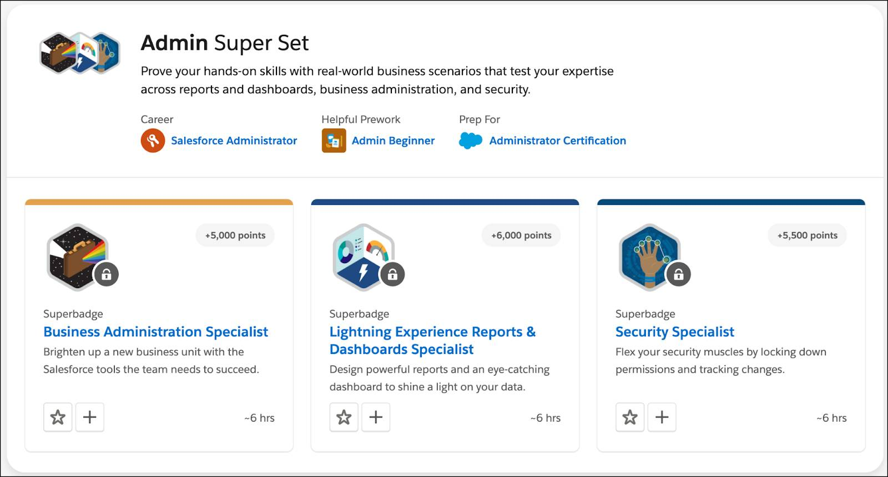

When you work through a superbadge, you’re doing the same work that many Salesforce admins and devs do every day. Because superbadges are skill-based and complex, you have to earn a few badges before you unlock each one to prove you’re ready to tackle the challenge.

**Mix Things Up with Trailmixes**

Trailhead has a lot of content, and it’s organized in different ways. That’s why we give you a way to group badges together and share them on your own terms. Remember how you used to make mixtapes in high school? A trailmix is like a mixtape, but of modules, projects, trails, and superbadges instead of songs.

To create a trailmix, hover over the **Learn** tab, click **Trailmixes**, then click **Create a trailmix**. Give your trailmix a name, description, and custom URL, then click **Next**. From there, Trailhead is your oyster. Click any module, trail, project, or superbadge to add it to your trailmix. Once you’ve created a mix to your liking, share it with anyone you’d like by sending them the unique URL.

**What’s the Today Page?**

Once you sign up for an account, you’re ready to dive in. The Today page is your launch pad. From here, you can navigate to recent groups and topics, favorite badges, and recommended learning paths and connections.  
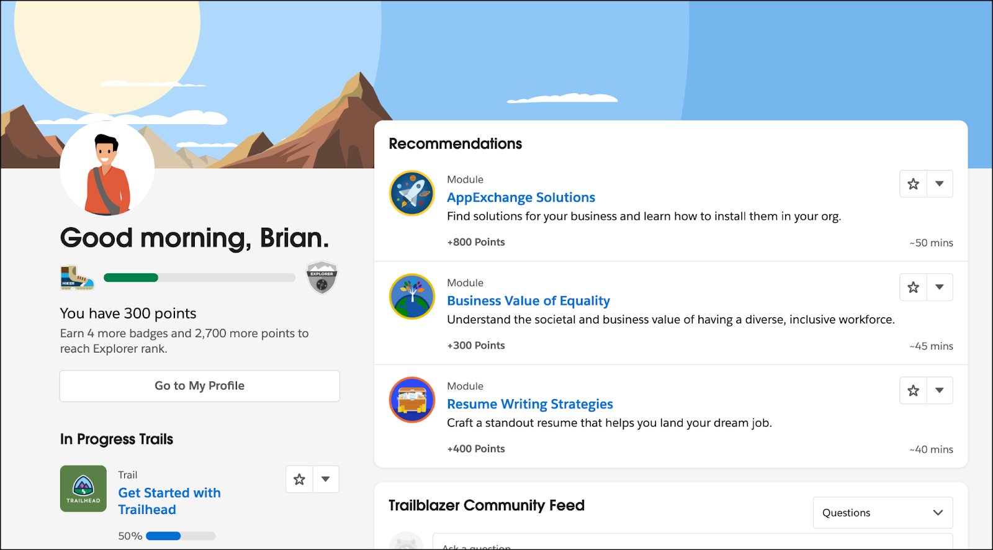

You can also see your favorites by clicking your profile image in the top-right corner of Trailhead and choosing **Favorites**. To favorite something, click  on a trail, module, post, topics, or superbadge’s tile.

**What’s the Trailblazer Community Feed?**

To drill down in your Community activity, go to the Trailblazer Community feed on the Today page. There, you can see new posts from the Trailblazers and topics you follow and the groups you’re a member of. And, more importantly, you can start asking and answering questions from other Trailblazers. Asking and answering questions is a great way to network with other Trailblazers, build up your own expertise, and help out Trailblazers like you.

Here’s a pro tip: Decide the type and frequency of email notifications you’d like to receive as you start to grow your feed by joining groups and following Trailblazers. To customize your email preferences, click your profile image in the top-right corner, select **Settings**, then select **Email Preferences**.

**What’s a Topic?**

Topics allow you to collaborate with Trailblazers from all over the world and discuss a specific area of interest. Search for and follow topics you’re interested in, or explore featured topics organized by product, role, or solution. When you view a topic you also see related learning, which shows you relevant Trailhead badges.

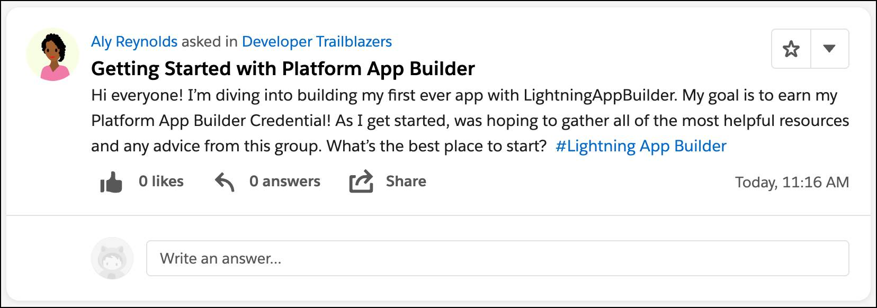

If you’re looking for a how-to or have a burning question, search for it—there’s a good chance you’re not the first Trailblazer to ask something. If you find a question similar to yours, you’ll see comments and answers from other Trailblazers and, if the original poster chose one, the best answer.

**What’s a Group?**

Groups are where Trailblazers with common interests gather to discuss multiple topics. A group can be private, public, or unlisted.

* **Public:** This group is visible to anyone, and anyone can join.
* **Private:** To join this group, the group owner or manager has to approve your request.
* **Unlisted:** You have to be invited to join this group.

Use groups to collaborate with Trailblazers on a range of interests. We recommend you start by exploring Featured Groups such as Release Readiness, Trailblazer Community Cove, and Lightning Now.

We talk more about groups, topics, and questions and answers in the next couple of units. For now, suffice it to say that they’re another great way for you to learn new things and make connections with Trailblazers around the world.